gsutil
gsutil is the command line tool used to manage buckets and objects on google cloud storage. gsutil is a Python application that lets you access Cloud Storage from the command line. You can use gsutil to do a wide range of bucket and object management tasks, including:
- Creating and deleting buckets.
- Uploading, downloading, and deleting objects.
- Listing buckets and objects.
- Moving, copying, and renaming objects.
- Editing object and bucket ACLs.
gsutil performs all operations, including uploads and downloads, using HTTPS and transport-layer security (TLS).
Important: gsutil is not the recommended CLI for Cloud Storage. Use gcloud storage commands in Google Cloud CLI instead.
Generally, you should use gcloud storage commands instead of gsutil commands:
- The gsutil tool is a legacy Cloud Storage CLI and minimally maintained.
- The gsutil tool does not support working with newer Cloud Storage features, such as soft delete and managed folders.
- gcloud storage commands require less manual optimization in order to achieve the fastest upload and download rates.
Note: The soft delete feature in Google Cloud Storage (GCS) is a data protection mechanism that helps prevent accidental or malicious deletion of objects and buckets. Instead of immediately and permanently deleting data, soft delete retains the deleted objects or buckets in a "soft-deleted" state for a specified retention period.

Cloud Storage
Cloud Storage is a managed service for storing unstructured data. Store any amount of data and retrieve it as often as you like. Cloud Storage is a service for storing your objects in Google Cloud. An object is an immutable piece of data consisting of a file of any format. You store objects in containers called buckets.
All buckets are associated with a project, and you can group your projects under an organization. Each project, bucket, managed folder, and object in Google Cloud is a resource in Google Cloud
After you create a project, you can create Cloud Storage buckets, upload objects to your buckets, and download objects from your buckets. You can also grant permissions to make your data accessible to principals you specify or accessible to everyone on the public internet. Public access in Google Cloud Storage (GCS) allows anyone on the internet to view or download files from your storage buckets without needing to authenticate with a Google account. It is commonly used for hosting static websites, sharing public datasets, or distributing media assets.
Access Control List (ACL) is a mechanism you can use to define who has access to your buckets and objects, as well as what level of access they have. ACL lets you control access to individual buckets or objects.
An Access Control List (ACL) in cloud storage is a mechanism used to define and manage permissions for accessing buckets and objects. ACLs specify which users or groups have specific levels of access (e.g., read, write, owner) to cloud storage resources. Through access control You control who has access to your Cloud Storage buckets and objects and what level of access they have.

Buckets
Buckets are the basic containers that hold your data as objects. Everything that you store in Cloud Storage must be contained in a bucket. You can use buckets to organize your data and control access to your data, but unlike directories and folders, you cannot nest buckets.
- There is no limit to the number of buckets you can have in a project or location.
- There are, however, limits to the rate you can create or delete buckets.
- When you create a bucket, you give it a globally-unique name and a geographic location where the bucket and its contents are stored.
- You cannot change the name of an existing bucket. Instead, you can create a new bucket with the name you want and move the contents from the old bucket to the new bucket. See Move and rename buckets for a step-by-step guide.
- Pricing (such as charges for data storage, data processing, and network outbound data transfer) depends on factors such as the bucket's location and the storage classes of objects within it. For more details, see Cloud Storage pricing.
- You can use Identity and Access Management (IAM) to control access to individual buckets.
When you create a bucket, you should decide whether you want to apply permissions using uniform or fine-grained access.
Uniform (recommended): Uniform bucket-level access allows you to use Identity and Access Management (IAM) alone to manage permissions. IAM applies permissions to all the objects contained inside the bucket or groups of objects with common name prefixes. IAM also allows you to use features that are not available when working with ACLs, such as managed folders, IAM Conditions, domain restricted sharing, and workforce identity federation.
Fine-grained: The fine-grained option enables you to use IAM and Access Control Lists (ACLs) together to manage permissions. ACLs are a legacy access control system for Cloud Storage designed for interoperability with Amazon S3. ACLs also allow you to specify access on a per-object basis.

Securing your data
Once you upload your objects to Cloud Storage, you have fine-grained control over how you secure and share your data. Here are some ways to secure the data you upload to Cloud Storage:
- Identity and Access Management: Use IAM to control who has access to the resources in your Google Cloud project. Resources include Cloud Storage buckets and objects, as well as other Google Cloud entities such as Compute Engine instances. You can grant principals certain types of access to buckets and objects, such as update, create, or delete.
- Data encryption: Cloud Storage uses server-side encryption to encrypt your data by default. You can also use supplemental data encryption options such as customer-managed encryption keys and customer-supplied encryption keys.
- Authentication: Ensure that anyone who accesses your data has proper credentials.
- Bucket Lock: Govern how long objects in buckets must be retained by specifying a retention policy.
- Soft delete: Prevent permanent loss of data against accidental or malicious deletion by retaining recently deleted objects and buckets. By default, Cloud Storage enables soft delete for all buckets with a seven day retention period.
- Object Versioning: When a live version of an object is replaced or deleted, it can be retained as a noncurrent version if you enable Object Versioning. It acts as a safeguard against accidental or malicious object updates, overwrites, or deletions, enabling recovery of previous states. When an object is overwritten, the previous live version becomes a noncurrent version, and the newly uploaded object becomes the new live version.
- Bucket IP filtering: With bucket IP filtering, you can restrict access to a bucket based on the source IP address of the request and secure your data from unauthorized access from specific IP addresses or Virtual Private Cloud (VPC).

Storage Classes
1) Standard storage: Standard storage is best for data that is frequently accessed ("hot" data), as well as data that is stored for only brief periods of time.
When used in a region, Standard storage is appropriate for storing data in the same location as Google Kubernetes Engine clusters or Compute Engine instances that use the data. Co-locating your resources maximizes the performance for data-intensive computations and can reduce network charges.
When used in a dual-region, you still get optimized performance when accessing Google Cloud products that are located in one of the associated regions, but you also get the improved availability that comes from storing data in geographically separate locations.
When used in a multi-region, Standard storage is appropriate for storing data that is accessed around the world, such as serving website content, streaming videos, executing interactive workloads, or serving data supporting mobile and gaming applications.

2) Nearline storage: Nearline is good for storing data accessed only every 30 days. Nearline storage is a low-cost, highly durable storage service for storing infrequently accessed data. Nearline storage is a better choice than Standard storage in scenarios where slightly lower availability, a 30-day minimum storage duration, and costs for data access are acceptable trade-offs for lowered at-rest storage costs.
Nearline storage is ideal for data you plan to read or modify on average once per month or less. For example, if you want to continuously add files to Cloud Storage and plan to access those files once a month for analysis, Nearline storage is a great choice.
Nearline storage is also appropriate for data backup, long-tail multimedia content, and data archiving. Note, however, that for data accessed less frequently than once a quarter, Coldline storage or Archive storage are more cost-effective, as they offer lower storage costs.

3) Coldline storage: Coldline is good for storing data accessed only every 90 days. Coldline storage is a very-low-cost, highly durable storage service for storing infrequently accessed data. Coldline storage is a better choice than Standard storage or Nearline storage in scenarios where slightly lower availability, a 90-day minimum storage duration, and higher costs for data access are acceptable trade-offs for lowered at-rest storage costs. Coldline is good for storing data accessed only every 90 days.
Coldline storage is ideal for data you plan to read or modify at most once a quarter. Note, however, that for data being kept entirely for backup or archiving purposes, Archive storage is more cost-effective, as it offers the lowest storage costs.

4) Archive storage: Archive storage is the best choice for data that you plan to access less than once a year. Archive storage is the lowest-cost, highly durable storage service for data archiving, online backup, and disaster recovery. Unlike the "coldest" storage services offered by other Cloud providers, your data is available within milliseconds, not hours or days.
Like Nearline storage and Coldline storage, Archive storage has a slightly lower availability than Standard storage. Archive storage also has higher costs for data access and operations, as well as a 365-day minimum storage duration. Archive storage is the best choice for data that you plan to access less than once a year. For example:
- Cold data storage - Archived data, such as data stored for legal or regulatory reasons, can be stored at low cost as Archive storage, yet still be available if you need it.
- Disaster recovery - In the event of a disaster recovery event, recovery time is key. Cloud Storage provides low latency access to data stored as Archive storage.
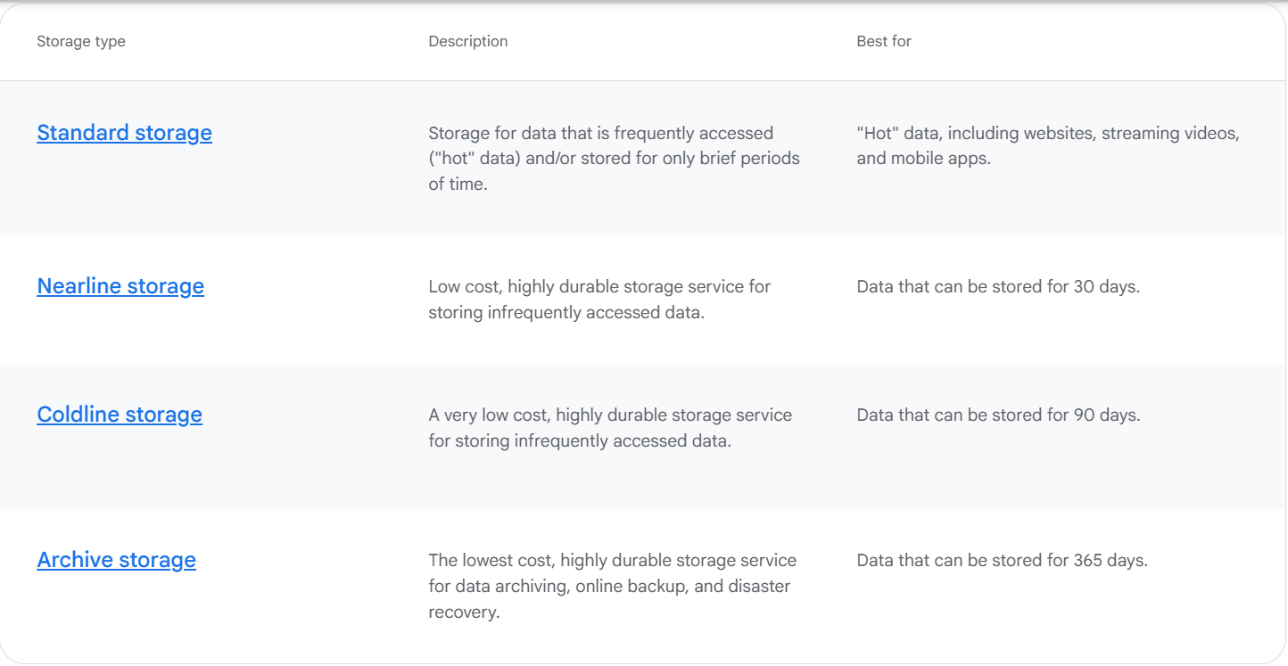

Key concepts of Storage Class
- A storage class is a piece of metadata that is used by every object.
- The storage class set for an object affects the object's availability and pricing model.
- When you create a bucket, you can specify a default storage class for the bucket. When you add objects to the bucket, they inherit this storage class unless explicitly set otherwise.
- If you don't specify a default storage class when you create a bucket, that bucket's default storage class is set to Standard storage.
- Changing the default storage class of a bucket does not affect any of the objects that already exist in the bucket.
- You can change the storage class of an existing object either by rewriting the object or by using Object Lifecycle Management.
Note: Google Cloud Storage's Object Lifecycle Management allows you to define automated rules in a bucket's lifecycle configuration to manage objects based on conditions like their age or name. These rules trigger actions such as moving objects to cheaper storage classes or deleting them, which helps reduce storage costs and simplifies manual data management.
- You can enable the Autoclass feature on a bucket to let Cloud Storage manage storage class transitions for you automatically.

Cloud Storage Features

Google BigQuery (built for analyzing historical data)
Google BigQuery is a fully managed, serverless enterprise data warehouse designed for large-scale data analytics which empowers you to focus on analytics instead of managing infrastructure. It allows high-speed SQL queries on massive datasets without management of the infrastructure, and it enables users to focus on insights rather than maintenance. Bigquery help you to get valuable insights from your data with ease.
BigQuery offers real-time analytics, scalability, and cost-effectiveness by allowing users to analyze large datasets quickly using SQL queries. Its serverless architecture eliminates the need for infrastructure management, enabling organizations to focus on insights rather than infrastructure.
Google BigQuery is a fully managed, serverless enterprise data warehouse that enables scalable analysis over petabytes of data. It is a key component of Google Cloud's data analytics platform.
Google BigQuery is designed to help businesses store and analyze large volumes of data quickly and efficiently. Whether you're dealing with massive datasets or real-time analytics,
BigQuery allows you to run complex queries and get insights in seconds without having to worry about managing servers or infrastructure. As part of Google Cloud, BigQuery integrates seamlessly with other Google Cloud services, such as Google Cloud Storage, Google Analytics, and Google Machine Learning, enabling you to build comprehensive data solutions.
BigQuery is a data warehouse offering optimized to query historical time-based data. BigQuery can run queries against data in its own column-based store or run federated queries against data from other data services and file stores. BigQuery is Google Cloud’s implementation of a modern data warehouse. BigQuery analyzes historical data and uses a SQL query engine.

Use Apache Beam via Cloud Dataflow to transform and load data into BigQuery. (ingest streaming data). Use Cloud Dataflow for real-time or batch processing.
- Clean, transform, and enrich data.
A dataset is contained within a specific project. Datasets are top-level containers that are used to organize and control access to your tables and views. A table or view must belong to a dataset, so you need to create at least one dataset before loading data into BigQuery. Use the format projectname.datasetname to fully qualify a dataset name when using GoogleSQL, or the format projectname:datasetname to fully qualify a dataset name when using the bq command-line tool.
A BigQuery table contains individual records organized in rows. Each record is composed of columns (also called fields). BigQuery stores table data in columnar format, meaning it stores each column separately. Column-oriented databases are particularly efficient at scanning individual columns over an entire dataset.
Every table is defined by a schema that describes the column names, data types, and other information. You can specify the schema of a table when it is created, or you can create a table without a schema and declare the schema in the query job or load job that first populates it with data.
In BigQuery, a schema defines the structure of a table—specifically:
- The fields (columns) in the table
- The name, data type, and mode (required/nullable/repeated) of each field
When you specify a table schema, you must supply each column's name and data type. You can also supply a column's description, mode, and default value.
Table types
The following sections describe the table types that BigQuery supports.
- Standard BigQuery tables: structured data stored in BigQuery storage.
- External tables: tables that reference data stored outside BigQuery.
- Views: logical tables that are created by using a SQL query.

BigQuery partitioning and clustering are optimization techniques used to improve query performance and reduce costs by limiting the amount of data scanned.
Partitioning:
Partitioning divides a large BigQuery table into smaller, more manageable segments called partitions based on the values of a specified column, typically a date or timestamp column. When a query filters on the partitioned column, BigQuery can perform "partition pruning," meaning it only scans the relevant partitions containing the data needed for the query, significantly reducing the amount of data processed and thus lowering query costs and improving performance.
Partitioning splits large tables into smaller segments, improving query performance by scanning only relevant data and reducing query cost.
- Time-based: By DATE, TIMESTAMP, DATETIME (e.g., daily sales_date partitions).
- Integer Range: By INTEGER values (e.g., user_id ranges).
- Ingestion-time: By data load timestamp (_PARTITIONDATE).
It is best for Time-series data and reducing query costs when filtering by date or numeric ranges.

Clustering:
Clustering further organizes data within partitions or within an unpartitioned table by sorting the data based on the values of one or more specified columns. When a query includes filters or aggregations on the clustered columns, BigQuery can leverage this organization to efficiently locate and process only the necessary data blocks, leading to faster query execution. Clustering is particularly beneficial for columns with high cardinality or those frequently used in WHERE or ORDER BY clauses. Clustering in bigquery organizes data within partitions based on specific columns, , improving query performance and reducing query cost.

Clustering organizes data within a table or partition by sorting it based on the values of specified columns, speeding up queries.
It is best for filtering and aggregating by frequently queried fields like region or user_id.
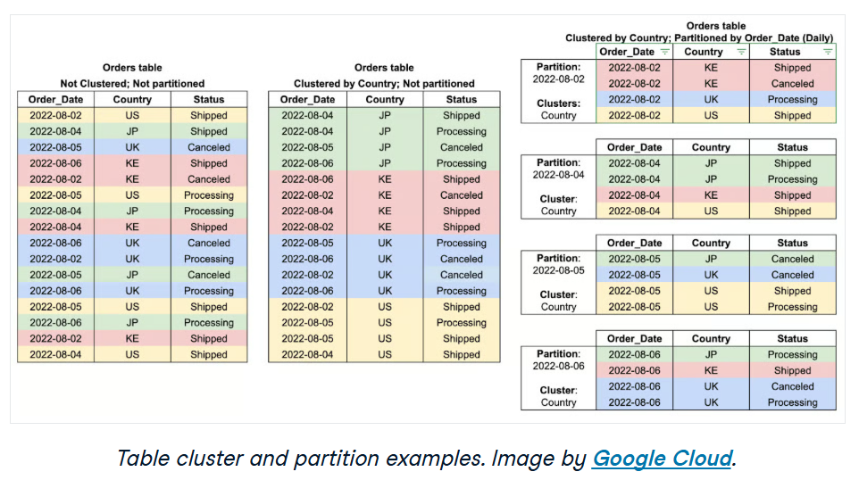
Clustering works best when combined with partitioning and provides even more performance benefits when working with large datasets.

BigQuery Data Transfer Service
The BigQuery Data Transfer Service enables you to move data into BigQuery from a variety of sources. Transfers can be both one-time, as well as ongoing or scheduled. The BigQuery Data Transfer Service automates data movement into BigQuery on a scheduled, managed basis.
For event-driven automation, Cloud Functions can execute BigQuery jobs in response to triggers from other Google Cloud services.

BigQuery supports nested and repeated fields in its schema, which makes it possible to model complex data structures (like JSON objects and arrays) directly inside a table. BigQuery allows for nested and repeated fields, enabling more efficient storage and querying of hierarchical or array-based data. Nested fields use the STRUCT data type, allowing a column to contain subfields, similar to a JSON object.
Repeated fields function as ARRAYS, enabling a single column to store multiple values. These structures help eliminate the need for complex JOIN operations, improve query performance, and make BigQuery well-suited for processing semi-structured data such as logs, event streams, and NoSQL-like datasets.

BigQuery offers multiple methods to schedule and automate jobs, ensuring recurring tasks run without manual intervention.
- Scheduled queries allow users to define recurring query executions directly through the BigQuery web UI or API.
- Cloud Scheduler provides a fully managed cron-like service that triggers queries at predefined intervals.
- For event-driven automation, Cloud Functions can execute BigQuery jobs in response to triggers from other Google Cloud services.

BigQuery Architecture
BigQuery’s serverless architecture decouples storage and compute and allows them to scale independently on demand. This structure offers both immense flexibility and cost controls for customers because they don’t need to keep their expensive compute resources up and running all the time. This is very different from traditional node-based cloud data warehouse solutions or on-premise massively parallel processing (MPP) systems. This approach also allows customers of any size to bring their data into the data warehouse and start analyzing their data using Standard SQL without worrying about database operations and system engineering.
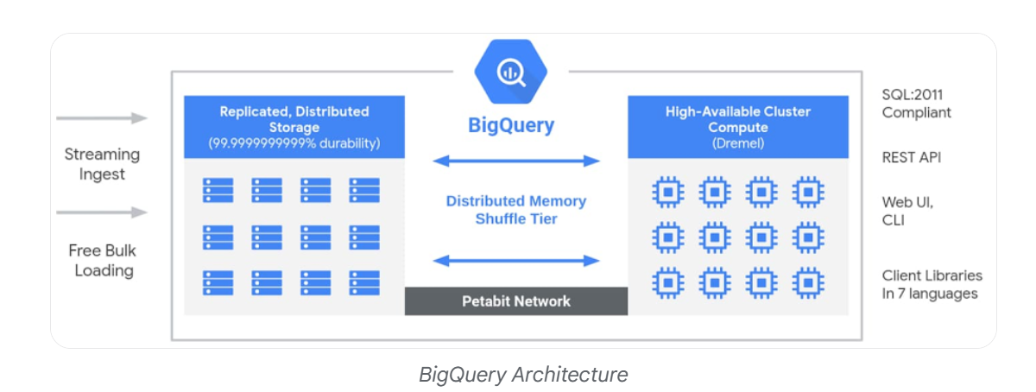
BigQuery is part of Google Cloud’s comprehensive data analytics platform that covers the entire analytics value chain including ingesting, processing, and storing data, followed by advanced analytics and collaboration. BigQuery is deeply integrated with GCP analytical and data processing offerings, allowing customers to set up an enterprise ready cloud-native data warehouse.
At each stage of the data lifecycle, GCP provides multiple services to manage data. This means customers can select a set of services tailored to their data and workflow.
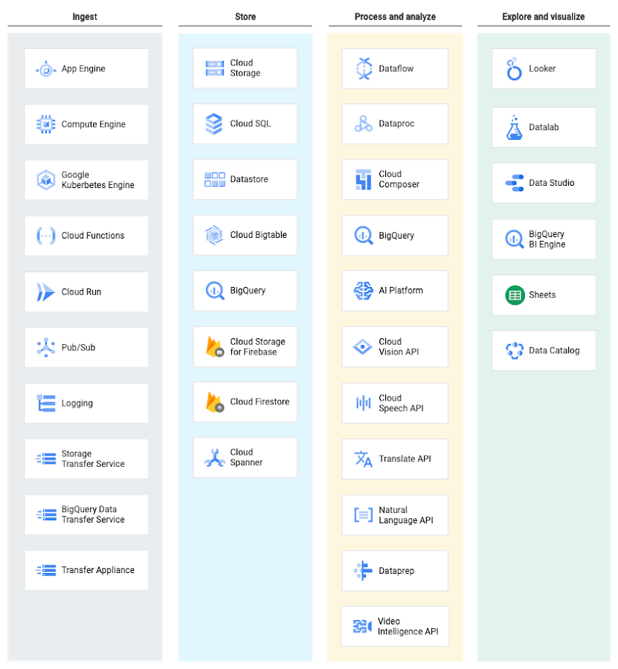

Cloud Spanner
Cloud Spanner is a fully managed, scalable, and globally distributed database service offered by Google Cloud. It combines the benefits of relational database structure with the scalability of non-relational databases, offering strong consistency and transactional support at a global scale.
Globally available and horizontally scalable
Cloud Spanner is a fully managed, mission-critical, relational database service that offers transactional consistency at global scale, schemas, SQL (ANSI 2011 with extensions), and automatic, synchronous replication for high availability.
Cloud Spanner offers:
- Strong consistency, including strongly consistent secondary indexes.
- SQL support, with ALTER statements for schema changes.
- Managed instances with high availability through transparent, synchronous, built-in data replication.
Cloud Spanner offers regional and multi-region instance configurations.

Cloud SQL:
Google Cloud SQL is a fully managed relational database service provided by Google Cloud. It enables users to deploy, manage, and scale relational databases without handling underlying infrastructure. Cloud SQL ensures high availability, automated backups, and built-in security. It integrates seamlessly with other Google Cloud services, making it ideal for modern cloud-native applications.
- Fully managed database administration with minimal operational overhead.
- High availability with automatic failover.
- Built-in backups, replication, and security features.
- Native integration with Google Cloud services.

Cloud SQL is a fully managed relational database service for MySQL, PostgreSQL, and SQL Server reducing your overall cost of operations and freeing up teams to focus on innovation. This frees you from database administration tasks so that you have more time to manage your data.
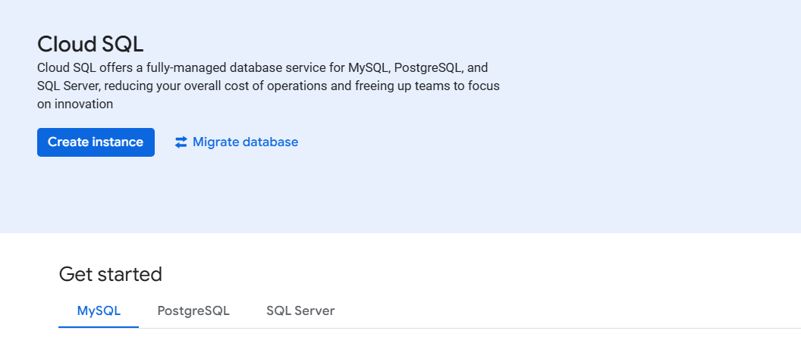
Use cases for Cloud SQL
Cloud SQL provides a cloud-based alternative to local MySQL, PostgreSQL, and SQL Server databases. You should use Cloud SQL if you want to spend less time managing your database and more time using it.
Many applications running on Compute Engine, App Engine and other services in Google Cloud use Cloud SQL for database storage.
Key Characteristics of Google Cloud SQL
The below characteristics make Google Cloud SQL a reliable, scalable, and low-maintenance database solution for applications that require structured data, high availability, and seamless cloud integration
1) Fully Managed Service
In a fully managed database model, organizations pay the cloud provider to handle the complete database infrastructure lifecycle.
- Google manages provisioning, patching, upgrades, and maintenance automatically.
- Built-in backup, restore, and failover capabilities ensure high availability.
- Eliminates the need for dedicated database administrators for routine operations.
- Enables teams to focus on application development and business productivity.
2) Relational Database System
A relational database is a database management system that stores structured data in a tabular format with clearly defined relationships.
- Data is organized into tables consisting of rows and columns.
- Relationships between tables are maintained using keys and constraints.
- Ensures data consistency and reliability across transactions.
- Structured Query Language (SQL): The standard language used to query, update, and manage relational databases.
- Data Integrity: Enforces accuracy, consistency, and completeness of data through constraints and validation rules.
Advantages of Google Cloud SQL
- Fully Managed Service: Google Cloud SQL is a fully managed service, meaning Google takes care of database management tasks such as patching, backups, and replication, allowing developers to focus on building applications.
- Scalability: Google Cloud SQL offers both vertical and horizontal scalability, allowing you to easily scale your database resources up or down based on your application's needs.
- High Availability: Google Cloud SQL provides built-in high availability with automatic failover, ensuring your databases remain accessible even in the event of hardware failures or maintenance events.
Disadvantages of Google Cloud SQL
- Limited Database Options: Google Cloud SQL currently supports only a limited set of database engines, including MySQL, PostgreSQL, and SQL Server. If you require support for other databases such as Oracle or MongoDB, you may need to consider alternative solutions.
- Vendor Lock-in: Using Google Cloud SQL may lock you into the Google Cloud Platform ecosystem, making it difficult to migrate to other cloud providers in the future.
- Cost: While Google Cloud SQL offers a range of pricing options, including pay-as-you-go and committed use discounts, running databases in the cloud can still incur significant costs, especially for large-scale deployments or resource-intensive workloads.

Create a Cloud SQL instance
In this quickstart, you use the Google Cloud console. To use the gcloud CLI, cURL, or PowerShell, see Create instances.
- In the Google Cloud console, go to the Cloud SQL Instances page.
- Click Create instance.
- Click Choose MySQL.
- In the Instance ID field, enter mysql-test.
- In the Password field, enter a password for the root user.
- Click Create instance.

Connect to your instance
At the Cloud Shell prompt, connect to your Cloud SQL instance. Use the gcloud sql connect command as follows.
gcloud sql connect mysql-test --user=root
Enter your root password. (Enter the password you used while creating the MySQL instance)
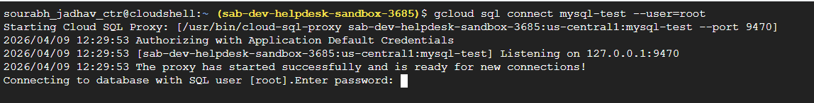

Create a database and upload data
Step 1: In order to create a database called guestbook on your Cloud SQL instance, you have to run the below SQL query
CREATE DATABASE guestbook;
Step 2: Insert the following sample data into the guestbook database by using SQL queries like use, create, insert, etc...
USE guestbook;

USE guestbook;
CREATE TABLE entries (guestName VARCHAR(255), content VARCHAR(255),
entryID INT NOT NULL AUTO_INCREMENT, PRIMARY KEY(entryID));
INSERT INTO entries (guestName, content) values ("first guest", "I got here!");
INSERT INTO entries (guestName, content) values ("second guest", "Me too!");

Step 3: Retrieve the data
SELECT * FROM entries;
Output
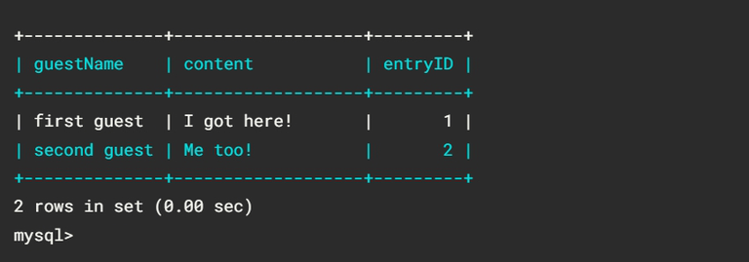

Cloud SQL does not support user-defined functions
--availability-type option allows you to specify zonal or regional availability, with regional providing automatic failover to a standby node in another region. When you use gcloud command to create cloud sql

Here's a brief comparison:
Feature | Cloud SQL | Cloud Spanner
Database type | Managed relational database (MySQL, PostgreSQL, SQL Server) | Globally distributed relational database
Scalability | Vertical scaling, limited horizontal scaling | Automatic horizontal scaling across regions
Availability | High availability within a region | Built for global, multi-region high availability
Consistency | Standard relational database consistency | Strong global consistency
Best for | Traditional web apps, small to medium workloads | Mission-critical, large-scale applications
Cost | Lower | Higher
In short:
- Cloud SQL → Best for typical applications that need a managed MySQL/PostgreSQL/SQL Server database.
- Cloud Spanner → Best for applications requiring massive scale, global distribution, and high availability with strong consistency.

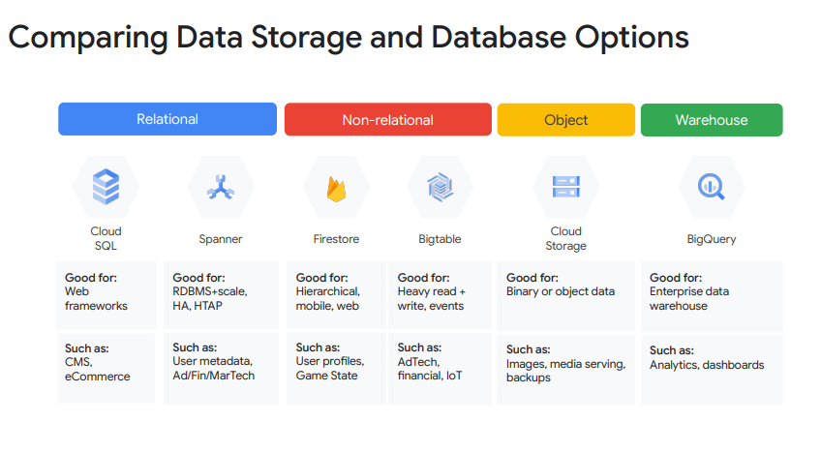

Serverless (cloud run, app engine, cloud function)
Cloud Run (Serverless compute service)
Cloud Run is a fully managed platform that enables you to run your code directly on top of Google’s scalable infrastructure. Cloud Run is simple, automated, and designed to make you more productive. Cloud run is used to deploy and scale applications fast and securely in a fully managed environment.
Cloud Run is a fully managed compute platform that enables you to run stateless containers that are invocable via v Pub/Sub events or HTTP web requests. Cloud Run is serverless: it abstracts away all infrastructure management, so you can focus on what matters most — building great applications. It is built from Knative that allows serving stateless containers in a serverless way and it’s natively portable.
Cloud Run is a managed compute platform that lets you run containers directly on top of Google's scalable infrastructure. Cloud Run provides serverless container management. Cloud Run lets developers spend their time writing their code, and very little time operating, configuring, and scaling their Cloud Run service. You don't have to create a cluster or manage infrastructure to be productive with Cloud Run. It lets you focus on code and you can deploy your solution quickly.
You can deploy code written in any programming language on Cloud Run if you can build a container image from it. In fact, building container images is optional. If you're using Go, Node.js, Python, Java, .NET Core, Ruby, or a supported framework you can use the source-based deployment option that builds the container for you, using the best practices for the language you're using.
A service that lets you run your applications in containers. Containers are like self-contained packages that include everything your application needs to run. Cloud Run makes it easy to deploy and scale these containerized applications. This is useful for more complex applications that might require specific software or configurations. For example, you could use Cloud Run to host a web application that uses the Gemini API to power a sophisticated chatbot.
On Cloud Run, your code can run as a service, job, or worker pool. All of these resource types run in the same environment and can use the same integrations with other services on Google Cloud.
Cloud Run services: A Cloud Run service provides you with the infrastructure required to run a reliable HTTPS endpoint. Your responsibility is to make sure your code listens on a TCP port and handles HTTP requests.
The following diagram shows a Cloud Run service running several container instances to handle web requests and events from the client using an HTTPS endpoint.
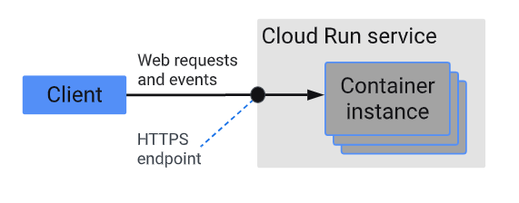
When to use Cloud Run services
Cloud Run services are great for code that handles requests, events, or functions. Example use cases include:
- Websites and web applications: Build your web app using your favorite stack, access your SQL database, and render dynamic HTML pages.
- APIs and microservices: You can build a REST API, a GraphQL API, or private microservices communicating over HTTP or gRPC.
- Streaming data processing: Cloud Run services can receive messages from Pub/Sub push subscriptions and events from Eventarc.
- Asynchronous workloads: Cloud Run functions can respond to asynchronous events, such as a message on a Pub/Sub topic, a change in a Cloud Storage bucket, or a Firebase event.
- AI inference: Cloud Run services, with or without GPU configured, can host AI workloads such as inference models and model training.
Cloud Run Jobs: Used to run code that performs work (a job)and quits when the work is done.

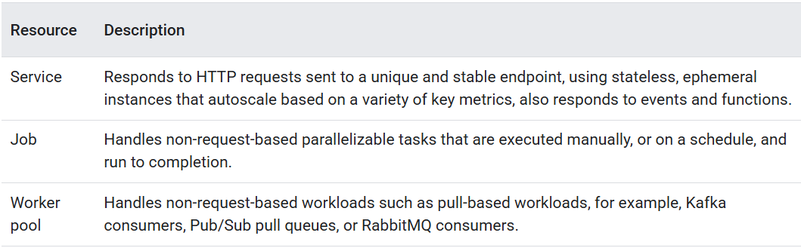
service are based on logic implemented in containers
Cloud Run allows you to run and execute containerized code in a highly concurrent environment.
• Runs containerized applications in a fully managed environment.
• You deploy your code as a container image.
• Automatically scales up/down based on requests.
Cloud Run is serverless, exposes your services as an endpoint, and abstracts all infrastructure.
Features
- Any Language: Users can use any programming language to build their application.
- Fully managed: There is no infrastructure to manage so if you have deployed any application, then Cloud Run will manage all the services for you. Google manages the underlying infrastructure, so you don't have to worry about servers or clusters.
- Auto-scaling: Cloud Run automatically scales your application up or down based on traffic.
- Portability: Google Cloud Run is built on the open‐source project named Knative which enables the portability of workloads across the platforms.
- Custom Domains: Cloud Run Maps the services to the domains of the users.
- Developing Experience: It provides a simple command‐line and user interface which helps in the quick deployment and management of your service.
- Redundancy: Google Cloud Run services are regional and automatically replicated across multiple zones.
- Event-driven: Cloud Run can also be triggered by events from services like Cloud Pub/Sub.
- HTTP Invocation: You can trigger your code via HTTP requests, making it suitable for web applications and APIs.
Use cases:
- Web applications and APIs: Cloud Run is ideal for building and deploying web applications and APIs.
- Microservices: Easily deploy and scale microservices with Cloud Run.
- Event-driven applications: Trigger your code based on events from various Google Cloud services.
- Data processing: Process data with Cloud Run functions, potentially integrating with other services like Cloud Storage or BigQuery.
- Background tasks: Run background tasks and jobs that are triggered by events or scheduled tasks.

Cloud Run functions (Cloud Functions is now Cloud Run functions — event-driven programming in one unified serverless platform)
Cloud Run Function is a 2nd gen cloud function and is based on cloud run.
Creating new 1st gen functions in the console is no longer supported. Creation is now only possible using the gcloud CLI, API, or Terraform.
Cloud Run Function is a serverless computing service offered by Google Cloud Platform (GCP). They provide a simple way to run code in response to events with minimal configuration and maintenance. Cloud Functions are event-driven, meaning they can be triggered by events such as changes in data, new messages, and user interactions.
Cloud Run functions manage your code as short, executable functions and does not manage your code in containers, which are more portable. These functions are designed to be event-driven, meaning they are triggered by specific events and perform a single, focused task. They are often used for tasks like processing data, integrating with other services, or handling HTTP requests. Cloud Run functions gives you the option of deploying your function code from the local directory where it resides. Cloud Run functions can respond to events from Google Cloud services, such as Cloud Storage, Pub/Sub, and Cloud Firestore to process files immediately after upload and generate thumbnails from image uploads, process logs, validate content, transcode videos, validate, aggregate, and filter data in real time.

Cloud Run functions is a lightweight compute solution for developers to create single-purpose, stand-alone functions that respond to Cloud events without the need to manage a server or runtime environment.
Google Cloud Functions is a serverless compute platform that allows you to run code in response to events without having to provision or manage servers. Because Cloud Function is a fully managed service, it is a great way to efficiently automate tasks, build microservices, and connect your applications to other cloud products and services, both on and off Google Cloud. Cloud Functions falls into the Functions as a Service (FaaS) category of computing. FaaS is all about the code–and just the code. With Google Cloud Functions, you have your choice of working with a range of runtimes: Go, Java, .NET Core, Node.js, PHP, Python or Ruby.
Small pieces of code that run in the cloud. They're triggered by specific events, like a new image being uploaded or a message being posted. You can use Cloud Run functions to automatically process these events using the Gemini API. For example, you could have a Cloud Run function that uses Gemini to automatically generate captions for uploaded images. The key benefit is that you don't have to manage any servers. Google takes care of all the infrastructure.
Cloud Functions serverless option is based on developing and executing small snippets of code.
Key points about Cloud Functions:
Event-driven: Cloud Functions are triggered by events, making them ideal for building responsive applications.
Small, focused code snippets: They are designed to execute small pieces of code, making them efficient for specific tasks.
Simplified infrastructure management: Cloud providers handle the underlying infrastructure, so developers can focus on writing code.
Scalability: Cloud Functions automatically scale up or down based on demand, ensuring resources are available when needed.
Support for Multiple Languages: Functions can be written in various supported programming languages like Node.js, Python, Go, Java, .NET Core, and Ruby.
Cloud Run: Deploy entire containerized applications. Cloud Run Functions: Deploy individual functions in supported languages.
All features
Connects and extends services to build complex applications:
Cloud Run functions lets you treat all Google and third-party cloud services as building blocks. Connect and extend them with code, and rapidly move from concept to production with end-to-end solutions and complex workflows. Further, integrate with third-party services that offer webhook integrations to quickly extend your application with powerful capabilities.

End-to-end development and diagnosability:
Go from code to deploy, with integrated monitoring. Get full observability and diagnosability for your application with Cloud Trace. Additionally, get support for local and disconnected development/debugging using open sourced functions framework.

Develop locally, scale globally:
Serve users from zero to planet-scale without even thinking about any infrastructure. Cloud Run functions automatically manages and scales underlying infrastructure with the size of workload.

No server management:
Deploy your code and let Google run and scale it for you. Cloud Run functions abstracts away all the underlying infrastructure, so that you can focus on your code and build applications faster than ever before.
Runs code in response to events:
Cloud Run functions allows you to trigger your code from Google Cloud, Firebase, and Google Assistant, or call it directly from any web, mobile, or backend application via HTTP.

Pay only for what you use:
You are only billed for your function’s execution time, metered to the nearest 100 milliseconds. You pay nothing when your function is idle. Cloud Run functions automatically spins up and backs down in response to events.

Avoid lock-in with open technology:
Use open source FaaS (function as a service) framework to run functions across multiple environments and prevent lock-in. Supported environments include, Cloud Run, local development environment, on-premises, and other Knative-based serverless environments.

Use cases
Integration with third-party services and APIs
Use Cloud Run functions to surface your own microservices via HTTP APIs or integrate with third-party services that offer webhook integrations to quickly extend your application with powerful capabilities, such as sending a confirmation email after a successful Stripe payment or responding to Twilio text message events.
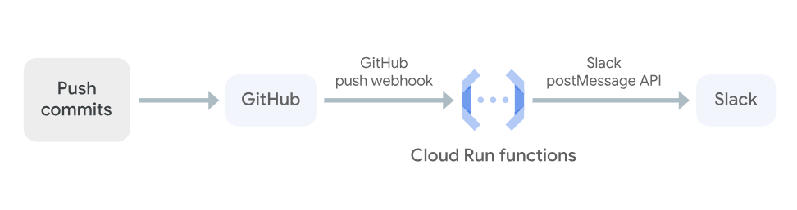
Serverless mobile backends
Use Cloud Run functions directly from Firebase to extend your application functionality without spinning up a server. Run your code in response to user actions, analytics, and authentication events to keep your users engaged with event-based notifications and offload CPU- and networking-intensive tasks to Google Cloud.
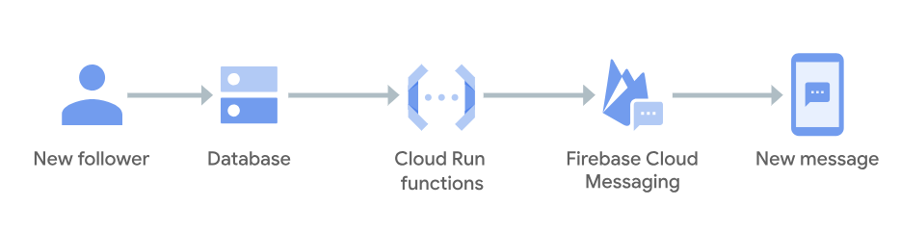

Serverless IoT backends
Use Cloud Run functions fully managed services to build backends for Internet of Things (IoT) device telemetry data collection, real-time processing, and analysis. Cloud Run functions allows you to apply custom logic to each event as it arrives.
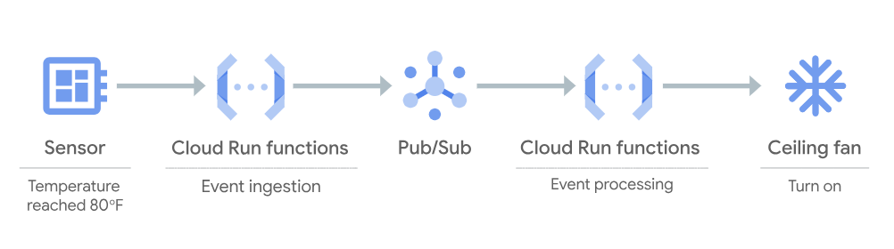
Real-time file processing
Execute your code in response to changes in data. Cloud Run functions can respond to events from Google Cloud services, such as Cloud Storage, Pub/Sub, and Cloud Firestore to process files immediately after upload and generate thumbnails from image uploads, process logs, validate content, transcode videos, validate, aggregate, and filter data in real time.
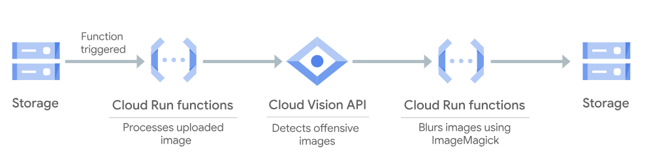
Real-time stream processing
Use Cloud Run functions to respond to events from Pub/Sub to process, transform, and enrich streaming data in transaction processing, click-stream analysis, application activity tracking, IoT device telemetry, social media analysis, and other types of applications.
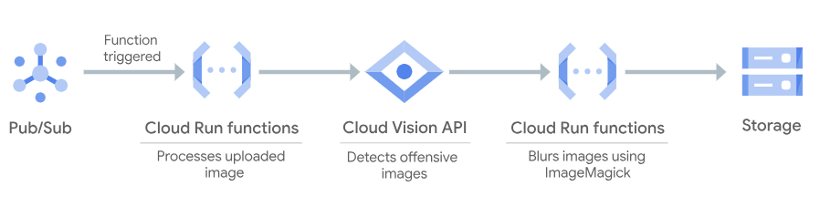
Virtual assistants and conversational experiences
Easily build artificial intelligence into your applications. Cloud Run functions with Cloud Speech API and Dialogflow can extend your products and services with voice- and text-based natural conversational experiences that help users get things done. Connect with users on Google Assistant, Amazon Alexa, Facebook Messenger, and other popular platforms and devices.
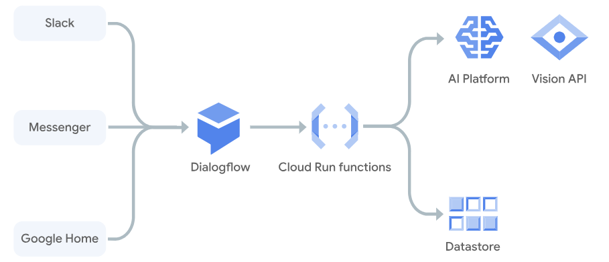
Video and image analysis
Use Cloud Run functions with Video Intelligence API and Cloud Vision API to retrieve relevant information from videos and images, enabling you to search, discover, and derive insight from your media content.
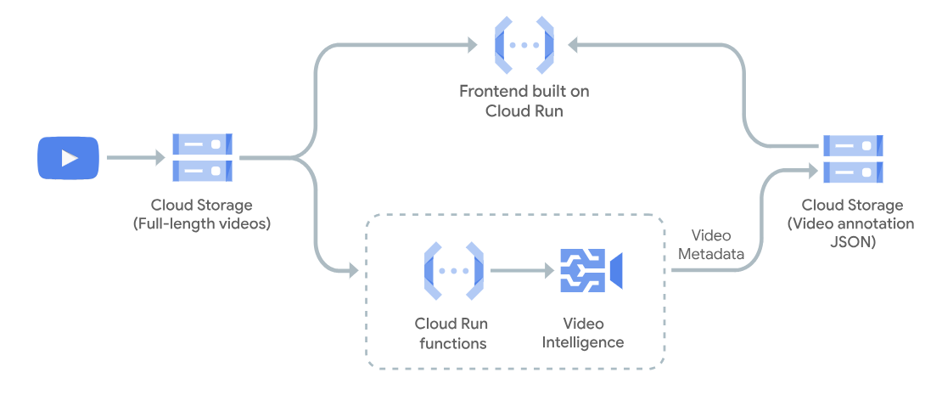

Sentiment analysis
Use Cloud Run functions in combination with Cloud Natural Language API to reveal the structure and meaning of text and add powerful sentiment analysis and intent extraction capabilities to your applications.
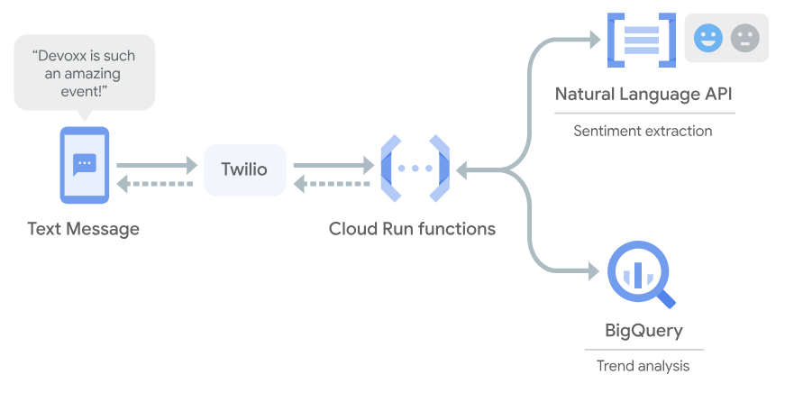

App Engine
Std and flexible environment
Google App Engine (GAE) is a fully managed, serverless Platform-as-a-Service (PaaS) that lets you build and deploy web applications without provisioning or managing infrastructure. It automatically scales resources up or down based on traffic, allowing you to focus entirely on writing code. Also supports versioning and traffic splitting.
Google App Engine is a fully managed Platform as a Service (PaaS) offering from Google Cloud Platform that enables developers to build, deploy, and scale applications without managing infrastructure.It automatically scales applications up or down based on demand while providing a secure and reliable runtime environment.
- Google App Engine is a scalable runtime environment primarily used for hosting web and mobile applications.
- Provides a secure execution environment along with built-in services for developing high-performance applications.
- Built-in services include cron jobs, communication services, scalable data stores, work queues, and in-memory caching.
Supported Environments
App Engine provides two environments to suit your application's needs: [1]
- Standard Environment: Highly secure, sandboxed instances with rapid scaling. It supports specific language versions of Python, Java, Node.js, PHP, Ruby, Go, and .NET. It is ideal for cost-effective, web-centric applications.
- Flexible Environment: Runs your application in Docker containers within Compute Engine instances. It allows you to utilize custom libraries, frameworks, or languages not supported in the standard environment.

You can run your applications in App Engine by using the App Engine flexible environment or the App Engine standard environment.
App Engine is well suited to applications that are designed using a microservice architecture, especially if you decide to utilize both environments. Use the following sections to learn and understand which environment best meets your application's needs.
When to choose the standard environment
Application instances run in a sandbox, using the runtime environment of a supported language listed below.
Applications that need to deal with rapid scaling.
The standard environment is optimal for applications with the following characteristics:
- Intended to run for free or at very low cost, where you pay only for what you need and when you need it. For example, your application can scale to 0 instances when there is no traffic.
- Experiences sudden and extreme spikes of traffic which require immediate scaling.
When to choose the flexible environment
Application instances run within Docker containers on Compute Engine virtual machines (VM).
Applications that receive consistent traffic, experience regular traffic fluctuations, or meet the parameters for scaling up and down gradually.
The flexible environment is optimal for applications with the following characteristics:
- Runs in a Docker container that includes a custom runtime or source code written in other programming languages.
- Uses or depends on frameworks that include native code.
- Accesses the resources or services of your Google Cloud project that reside in the Compute Engine network.

Feature |  | Standard Environment |  | Flexible Environment
Scaling Speed |  | Rapid; scales to zero |  | Slower; minimum 1 instance
Runtime |  | Specific versions (e.g., Python 3.12) |  | Any via Docker containers
Startup Time |  | Seconds |  | Minutes
Use Case |  | Apps with sudden traffic spikes |  | Consistent traffic; custom OS needs
Feature [1, 2, 3, 4, 5] | Standard Environment |  | Flexible Environment
Scaling | Scales dynamically from 0 to thousands of instances. Shuts down entirely when idle, incurring zero cost. |  | Always scales to at least 1 instance. Cannot scale to zero, meaning you pay baseline VM costs regardless of traffic.
Startup Time | Instances spin up in milliseconds (handles traffic spikes extremely well). |  | Instances take minutes to spin up (similar to standard Compute Engine VMs).
Customization | Restricted to specific language versions. Cannot use native libraries outside those provided by Google's runtime. |  | Full access to the underlying OS and compute resources. You can install custom native libraries and utilize custom Docker containers.
Request Timeout | Shorter timeouts (typically 60 seconds for HTTP requests). |  | Longer timeouts allowed (ideal for long-running processes).
Background Work | Limited. Background threads are constrained and must finish quickly. |  | Unlimited. Allows background threads and long-running background tasks.
Pricing | Highly cost-effective for spiky or low-traffic sites. Generous free tier included. |  | Billed based on the CPU and memory of the underlying VM. More predictable for steady, sustained traffic.
When to Choose Which?
- Choose Standard if: You are building a web application using standard runtimes (Java, Python, Go, PHP, Node.js, or Ruby), you want to benefit from a generous free tier, and your traffic is highly variable or frequently drops to zero.
- Choose Flexible if: You need to use languages/frameworks outside the supported list, you require specific native C/C++ dependencies in your code, or your application needs steady, predictable baseline performance without cold starts. [1, 2]

Pub/Sub`
Pub/Sub is an asynchronous and scalable messaging service that decouples services producing messages from services processing those messages. Pub/Sub allows services to communicate asynchronously, with latencies typically on the order of 100 milliseconds.
Cloud Pub/Sub is a fully managed, real-time messaging service from Google Cloud that allows independent applications to communicate asynchronously. It works by decoupling senders (publishers) from receivers (subscribers) by creating a central topic where publishers send messages and subscribers receive them. This creates a robust, scalable, and resilient system that simplifies application integration and event-driven architecture.
Pub/Sub is used for streaming analytics and data integration pipelines to load and distribute data. It's equally effective as a messaging-oriented middleware for service integration or as a queue to parallelize tasks.
Pub/Sub lets you create systems of event producers and consumers, called publishers and subscribers. Publishers communicate with subscribers asynchronously by broadcasting events, rather than by synchronous remote procedure calls (RPCs).
cloud solution monitors Pub/Sub for incoming sensor data, triggers a Cloud Run function as new messages are posted to a specific topic, and starts a Dataflow job to transform data and save it into Bigtable.

Common use cases
- Ingesting user interaction and server events. To use user interaction events from end-user apps or server events from your system, you might forward them to Pub/Sub. You can then use a stream processing tool, such as Dataflow, which delivers the events to databases. Examples of such databases are BigQuery, Bigtable, and Cloud Storage. Pub/Sub lets you gather events from many clients simultaneously.
- Real-time event distribution. Events, raw or processed, may be made available to multiple applications across your team and organization for real- time processing. Pub/Sub supports an "enterprise event bus" and event-driven application design patterns. Pub/Sub lets you integrate with many systems that export events to Pub/Sub.
- Replicating data among databases. Pub/Sub is commonly used to distribute change events from databases. These events can be used to construct a view of the database state and state history in BigQuery and other data storage systems.
- Parallel processing and workflows. You can efficiently distribute many tasks among multiple workers by using Pub/Sub messages to communicate with the workers. Examples of such tasks are compressing text files, sending email notifications, evaluating AI models, and reformatting images.
- Enterprise event bus. You can create an enterprise-wide real-time data sharing bus, distributing business events, database updates, and analytics events across your organization.
- Data streaming from applications, services, or IoT devices. For example, a SaaS application can publish a real-time feed of events. Or, a residential sensor can stream data to Pub/Sub for use in other Google Cloud products through a data-processing pipeline.
- Refreshing distributed caches. For example, an application can publish invalidation events to update the IDs of objects that have changed.
- Load balancing for reliability. For example, instances of a service may be deployed on Compute Engine in multiple zones but subscribe to a common topic. When the service fails in any zone, the others can pick up the load automatically.

Cloud Build (cloud build serverless CICD platform)
Build, test, and deploy on our serverless CI/CD platform.
Cloud Build is a service that executes your builds on Google Cloud infrastructure. Cloud Build can import source code from Cloud Storage, GitLab, GitHub, or Bitbucket, execute a build to your specifications, and produce artifacts such as Docker containers or Java archives.
Cloud Build is a service provided by Google Cloud Platform (GCP) that allows you to automate the building, testing, and deployment of your software applications. Cloud Build can help you improve the speed and reliability of your software delivery process, as well as simplify the management of your infrastructure.

Features & Benefits
Cloud Build is a fully serverless platform that helps you build custom development workflows for building, testing, and deploying.
Continuous Integration and Delivery (CI/CD): Cloud Build provides an automated CI/CD pipeline that allows you to build, test, and deploy your code to GCP services like Container Registry, App Engine, or Kubernetes Engine.
Source Code Management: Cloud Build integrates with popular source code management tools like GitHub, Bitbucket, and Cloud Source Repositories, allowing you to build and deploy your code from your preferred repository.
Supports Native Docker: Cloud Build allows you to import your existing Docker file and Push images directly to Docker image storage repositories such as Docker Hub and Container Registry.
Artifiact registry: A universal package manager for all your build artifacts and dependencies. Fast, scalable, reliable and secure.
Artifact analysis: Provides vulnerability scanning and metadata storage for containers on Google Cloud
Cloud deploy: Cloud Deploy is a service that automates delivery of your applications to a series of target environments in a defined sequence.

Cloud Scheduler is a fully managed, enterprise-grade cron job service on Google Cloud that lets you schedule tasks (cron jobs) to run at defined times or intervals (to run automatically at specific intervals).
Cloud Scheduler provides a fully managed cron-like service that triggers queries at predefined intervals.
A cron job is a time-based job scheduler in Unix-like operating systems (like Linux and macOS) that allows you to automate tasks by scheduling commands or scripts to run automatically at specific intervals. It's essentially a way to set up recurring tasks without manual intervention, ensuring that important, routine processes are executed consistently.
A CronJob creates Jobs on a repeating schedule.
CronJob is meant for performing regular scheduled actions such as backups, report generation, and so on.
A schedule is defined using the unix-cron string format (* * * * *) which is a set of five fields in a line, indicating when the job should be executed.
The time fields have the following format and possible values, and must follow this order:
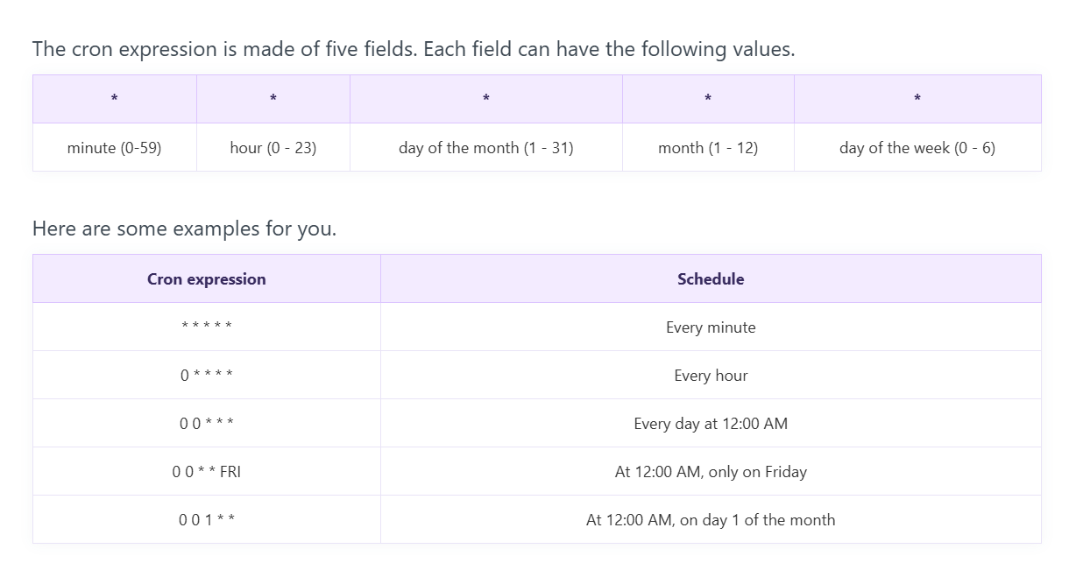
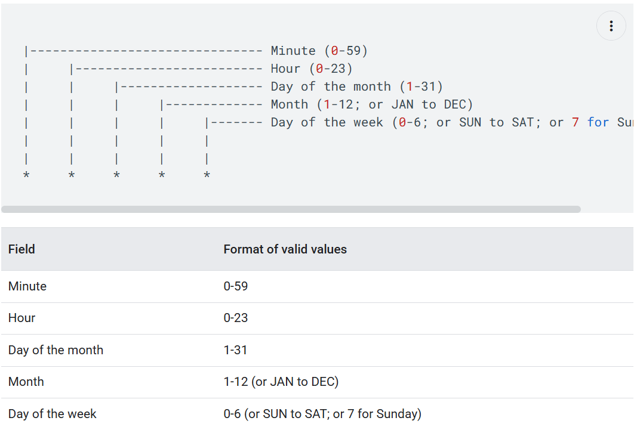
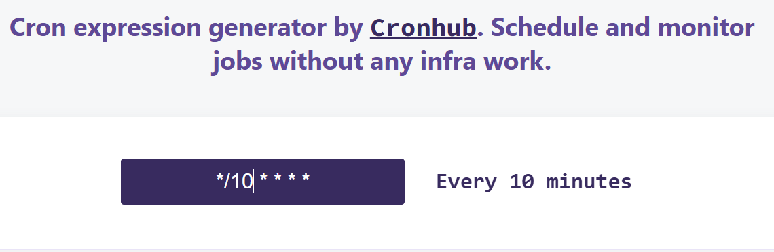
- */2 * * * *: the job runs every two minutes.

Identity-Aware Proxy
IAP lets you establish a central authorization layer for applications accessed by HTTPS, so you can use an application-level access control model instead of relying on network-level firewalls.
IAP policies scale across your organization. You can define access policies centrally and apply them to all of your applications and resources. When you assign a dedicated team to create and enforce policies, you protect your project from incorrect policy definition or implementation in any application.
IAP is a Google Cloud service that adds an additional layer of security to your applications running on Google Cloud. IAP uses Google Cloud Identity and Access Management (IAM) to authenticate users and then uses role-based access control (RBAC) to determine what resources users have access to.
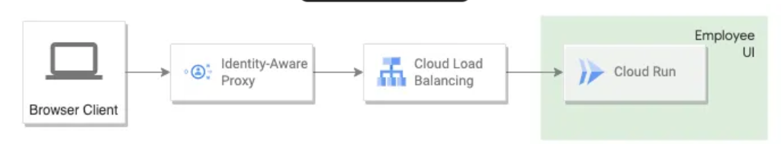

When to use IAP
Use IAP when you want to enforce access control policies for applications and resources. IAP works with signed headers or the App Engine standard environment Users API to secure your app. With IAP, you can set up group-based application access: a resource could be accessible for employees and inaccessible for contractors, or only accessible to a specific department.

Cloud Composer (A fully managed workflow orchestration service built on Apache Airflow)
Cloud Composer is a fully managed workflow orchestration service, enabling you to create, schedule, monitor, and manage workflow pipelines that span across clouds and on-premises data centers. Cloud Composer is built on the popular Apache Airflow open-source project and operates using the Python programming language. Cloud Composer is built on the popular Apache Airflow open-source project and operates using the Python programming language. By using Cloud Composer instead of a local instance of Apache Airflow, you can benefit from the best of Airflow with no installation or management overhead. Cloud Composer helps you create Airflow environments quickly and use Airflow-native tools, such as the powerful Airflow web interface and command-line tools, so you can focus on your workflows and not your infrastructure. Composer tasks are defined in the form of a Python Directed Acyclic Graphs (DAG)
Cloud Composer, also known as BigQuery Engine for Apache Airflow, is a managed Apache Airflow service that helps you create, schedule, monitor and manage workflows. Cloud Composer helps you create managed Airflow environments quickly and use Airflow-native tools, such as the powerful Airflow web interface and command-line tools, so you can focus on your workflows and not your infrastructure.
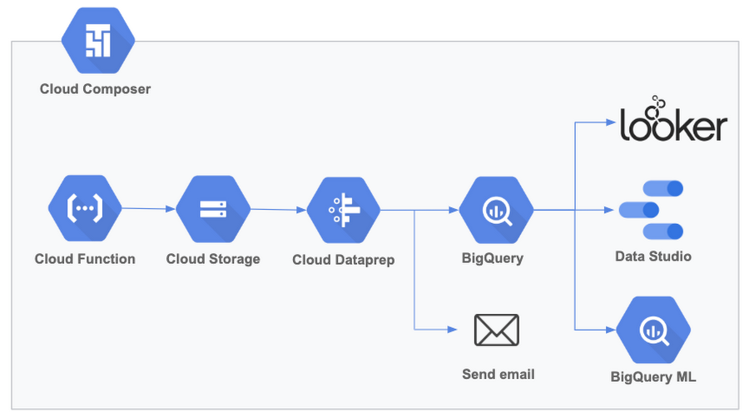
Apache Airflow is an open-source platform used for programmatically author, schedule and monitor workflows. It is widely adopted in data engineering for orchestrating complex data pipelines and other batch-oriented processes. Apache Airflow is an open-source platform for developing, scheduling, and monitoring batch-oriented workflows. Airflow’s extensible Python framework enables you to build workflows connecting with virtually any technology. A web-based UI helps you visualize, manage, and debug your workflows. You can run Airflow in a variety of configurations — from a single process on your laptop to a distributed system capable of handling massive workloads.
In data analytics, a workflow represents a series of tasks for ingesting, transforming, analyzing, or utilizing data. In Airflow, workflows are created using DAGs, or "Directed Acyclic Graphs". An Airflow DAG is a collection of tasks that you want to schedule and run, organized in a way that reflects their relationships and dependencies. DAGs are created in Python files, which define the DAG structure using code. The DAG's purpose is to ensure that each task is executed at the right time and in the right order. A DAG is a model that encapsulates everything needed to execute a workflow. Some DAG attributes include the following:
- Schedule: When the workflow should run.
- Tasks: tasks are discrete units of work that are run on workers.
- Task Dependencies: The order and conditions under which tasks execute.
- Callbacks: Actions to take when the entire workflow completes.
- Additional Parameters: And many other operational details.
- Contains:
  - DAG definition (name, schedule, default args)
  - Tasks (like BashOperator, PythonOperator, etc.)
  - Dependencies (using >> or << to define order)

(Note: A workflow is a series of tasks or steps that need to be performed in a specific order to achieve a goal. And Orchestration is the automation, management and coordination of workflow to ensure they run in the right sequence, at the right time, and handle failures or retries if needed.)
With Airflow, users can author workflows as Directed Acyclic Graphs (DAGs) of tasks. Airflow’s rich user interface makes it easy to visualize pipelines running in production, monitor progress, and troubleshoot issues when needed. It connects with multiple data sources and can send an alert via email or Slack when a task completes or fails. Airflow is distributed, scalable, and flexible, making it well-suited to handle the orchestration of complex business logic.

A Cloud Composer environment is a fully managed Apache Airflow service on Google Cloud. It provisions and manages the necessary Google Cloud services to run your Airflow workflows.
Cloud Composer Environments are self-contained Airflow deployments based on Google Kubernetes Engine, and they work with other Google Cloud services using connectors built into Airflow. You can create one or more environments in a single Google Cloud project. You can create Cloud Composer environments in any supported region.
Every Cloud Composer environment has a Cloud Storage bucket associated with it. This bucket, also called environment's bucket, stores the DAGs, logs, custom plugins, and data for the environment. Environment's bucket is located in the customer project. Airflow in Cloud Composer schedules only DAGs that are located in the /dags folder in this bucket. When you upload your DAG files to the /dags folder in your environment's bucket, Cloud Composer synchronizes the DAGs to Airflow components of your environment.

Use cases
- Data pipeline orchestration (ETL/ELT): Automating complex data workflows, including extraction, transformation, and loading (ETL/ELT) jobs, and managing dependencies between tasks.
- MLOps & machine learning workflows: Orchestrating the end-to-end ML lifecycle, from data preparation and model training/evaluation to deployment and monitoring.
- Business intelligence (BI) automation: Scheduling data extractions for BI tools, automating report generation, and refreshing dashboards.
- Infrastructure and DevOps automation: Automating cloud infrastructure tasks like provisioning and decommissioning clusters, submitting jobs, and managing CI/CD release processes.
- Hybrid and multi-cloud data integration: Coordinating data flows across diverse sources, including other cloud providers and on-premises data centers, to create unified datasets.
Airflow Operators are the building blocks of Airflow DAGs (Directed Acyclic Graphs), and they define what tasks should be executed in your workflows. I hope you guys now have a basic understanding of Airflow.
In Apache Airflow, an Operator is a predefined template that encapsulates the logic of a specific task in a workflow. Each task in a DAG is associated with an operator, which defines what the task will do. Operators don’t actually execute the code but describe how a task should be executed.
Broadly speaking, Operators can be divided into the following categories:
- Action Operators: Perform an action, such as executing a Python function, running a shell command, or making an HTTP request.
- Transfer Operators: Move data from one system to another, like transferring files between databases or from an FTP server to cloud storage.
- Sensor Operators: Wait for a certain condition to be met before proceeding, like waiting for a file to land in a directory or for an API to respond.
Airflow Operators are the fundamental building blocks defining individual tasks within a Directed Acyclic Graph (DAG), dictating what work gets done, like running a Python script (PythonOperator), executing a Bash command (BashOperator), or querying a database ( PostgresOperator). An Operator is conceptually a template for a predefined Task, that you can just define declaratively inside your DAG
Airflow has a very extensive set of operators available, with some built-in to the core or pre-installed providers. Some popular operators from core include:
- BashOperator - executes a bash command
- PythonOperator - calls an arbitrary Python function
- EmailOperator - sends an email

Scenario: You have data files landing in GCS daily, and you want to process them and load them into BigQuery.
- Cloud Composer: Orchestrates the workflow — waits for files, cleans them, triggers a Dataflow job, loads the result into BigQuery, and sends an alert.
- BigQuery: Executes the SQL-based analytics or dashboards on the final loaded data.

Real-World Use Case Example
Use Case: Automate daily sales reporting.
- Step 1: GCS file arrives at midnight.
- Step 2: Cloud Composer DAG triggers.
- Step 3: Composer calls a Dataflow job to clean data.
- Step 4: Loads cleaned data into BigQuery table.
- Step 5: Runs BigQuery SQL to update daily summary table.
Note: To execute the SQL query in a specific BigQuery database you can use BigQueryInsertJobOperator with proper query job configuration that can be Jinja templated.
- Step 6: Sends email report via Composer.
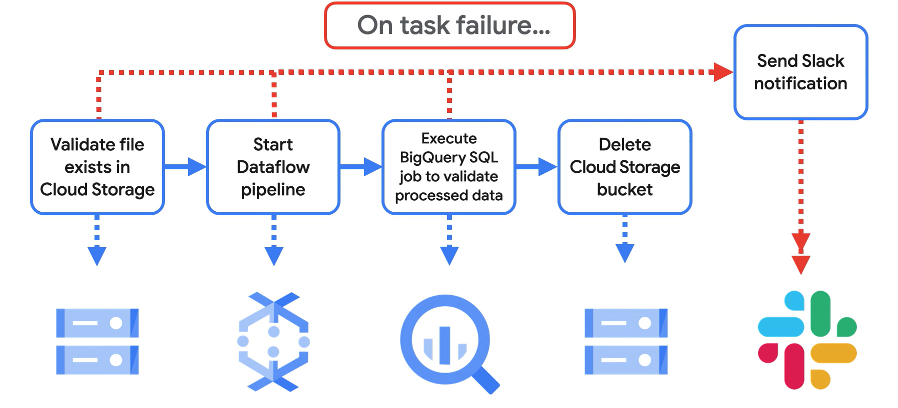

Create an environment
- In the Google Cloud console, go to the Create environment page.
Go to Create environment
- In the Name field, enter example-environment.
- In the Location drop-down list, select a region for the Cloud Composer environment. This guide uses us-central1 region.
- For other environment configuration options, use the provided defaults.
- Click Create and wait until the environment is created.

Create a DAG file
An Airflow DAG is a collection of organized tasks that you want to schedule and run. DAGs are defined in standard Python files.
This guide uses an example Airflow DAG defined in the quickstart.py file. Python code in this file does the following:
- Creates a DAG, composer_sample_dag. This DAG runs every day.
- Executes one task, print_dag_run_conf. The task prints the DAG run's configuration by using the bash operator.
Save a copy of the quickstart.py file on your local machine:
from airflow import models
from airflow.operators import bash
from airflow import DAG
from airflow.operators.bash_operator import BashOperator
from datetime import datetime

# If you are running Airflow in more than one time zone
# see https://airflow.apache.org/docs/apache-airflow/stable/timezone.html
# for best practices
YESTERDAY = datetime.datetime.now() - datetime.timedelta(days=1)

default_args = {
"owner": "Composer Example",
"depends_on_past": False,
"email": [""],
"email_on_failure": False,
"email_on_retry": False,
"retries": 1,
"retry_delay": datetime.timedelta(minutes=5),
"start_date": YESTERDAY,
}

with models.DAG(
"composer_quickstart",
catchup=False,
default_args=default_args,
schedule_interval=datetime.timedelta(days=1),
) as dag:
# Print the dag_run id from the Airflow logs
print_dag_run_conf = bash.BashOperator(
task_id="print_dag_run_conf", bash_command="echo {{ dag_run.id }}"
)

Upload the DAG file to your environment's bucket
Every Cloud Composer environment has a Cloud Storage bucket associated with it. Airflow in Cloud Composer schedules only DAGs that are located in the /dags folder in this bucket.
To schedule your DAG, upload quickstart.py from your local machine to your environment's /dags folder:
- In the Google Cloud console, go to the Environments page.
Go to Environments
- In the list of environments, click the name of your environment, example-environment. The Environment details page opens.
- Click Open DAGs folder. The Bucket details page opens.
- Click Upload files and then select your copy of quickstart.py.
- To upload the file, click Open.

Workflow
In Google Cloud Platform (GCP), Workflows is a serverless orchestration service that lets you connect and automate sequences of tasks (steps) involving various GCP services, external APIs, and custom code, all defined in a YAML-based language for reliability, error handling, and stateful execution, perfect for microservices, data pipelines, and business process automation. It manages the underlying complexities of API calls, authentication, and retries, allowing developers to focus on logic, not glue code.
Cloud Workflows is a fully managed service offered by Google Cloud Platform (GCP) that enables you to build and run serverless workflows with a visual designer and a range of pre-built connectors. With Cloud Workflows, you can easily automate and orchestrate business processes, data processing pipelines, and other types of workflows.
Key Concepts & Features
- Orchestration: Combines multiple services (Cloud Functions, Run, Pub/Sub, BigQuery, external HTTP APIs) into a single, automated flow.
- Serverless: Fully managed, scales automatically, and you pay only for execution, with no cold starts.
- YAML Definition: Workflows are defined using a declarative YAML syntax, making them readable and maintainable.
- Connectors: Simplifies calling other GCP services by handling request formatting and authentication.
- Stateful & Durable: Can run for up to a year, handling long-running operations and waiting for external callbacks (HTTP requests).
- Error Handling: Built-in retries, conditional logic (expressions), and failure handling for resilient processes.
- Event-Driven: Can be triggered by events from other GCP services like Cloud Storage or Pub/Sub via Eventarc.
- Monitoring: Integrates with Cloud Logging for visibility into executions, steps, and errors.
Use Cases
- Microservices Chaining: Connecting different microservices for complex application logic.
- Data Processing: Orchestrating ETL/ELT pipelines, triggering jobs in Dataflow or BigQuery.
- Automation: Automating infrastructure tasks like provisioning or starting/stopping VMs.
- Human-in-the-Loop: Waiting for external approvals via HTTP callbacks.
When to Use Workflows vs. Composer
- Workflows:
Best for orchestrating API calls, microservices, and event-driven tasks with low latency requirements and complex logic/error handling.
- Cloud Composer:
(Built on Airflow) Better for large, batch-oriented data pipelines (ETL/ELT) where logic is defined in Python DAGs and latency between tasks can be higher.

ETL
ETL describes the end-to-end process by which a company takes its full breadth of data—structured and unstructured and managed by any number of teams from anywhere in the world—and gets it to a state where it’s actually useful for business purposes.
ETL stands for extract, transform and load and is a traditionally accepted way for organizations to combine data from multiple systems into a single database, data store, data warehouse, or data lake. ETL can be used to store legacy data, or—as is more typical today—aggregate data to analyze and drive business decisions. Goal of ETL pipeline is to make raw data available for analytics and business intelligence.
Why is ETL important?
ETL (Extract, Transform, Load) has been a cornerstone of data integration for decades, and remains relevant in modern data architectures. ETL offers several potential advantages:
- Data quality: Data quality and consistency are often improved in ETL processes through cleansing and transformation steps
- Data governance: ETL can help enforce data governance policies by ensuring that data is transformed and loaded into the target system in a consistent and compliant manner
- Legacy systems: ETL is often used to integrate data from legacy systems that may not be compatible with modern data architectures
- Complex transformations: ETL tools often provide a wide range of transformation capabilities, making them suitable for complex data manipulation tasks
How cloud-based ETL works
- Extraction is the process of retrieving data from one or more sources—online, on-premises, legacy, SaaS, or others. After the retrieval, or extraction, is complete, the data is loaded into a staging area.
- Transformation involves taking that data, cleaning it, and putting it into a common format, so it can be stored in a targeted database, data store, data warehouse, or data lake. Cleaning typically involves taking out duplicate, incomplete, or obviously erroneous records.
- Loading is the process of inserting that formatted data into the target database, data store, data warehouse, or data lake.

ETL vs. ELT
While ETL and ELT serve as data integration methods, their distinction lies in the timing of data transformation. ETL processes data by transforming it prior to loading it into the destination system. In ELT, data is loaded into the target system in its raw format and then transformed.
The choice between ETL and ELT depends on several factors, including:
- Data volume: ELT is generally better suited for large volumes of data because it leverages the processing power of cloud data warehouses
- Data complexity: ETL is often used for complex transformations that require specialized tools and expertise
- Target system: ELT is best suited for cloud-based data warehouses and data lakes that have the processing power to handle transformations
- Skills and resources: ETL requires specialized skills and resources for building and maintaining transformation pipelines. ELT may be easier to implement because it leverages the resources of cloud data warehouses

ETL use cases
ETL is an important way to bring all relevant data together in one place to make it actionable—to analyze it and enable executives, managers, and other stakeholders to make informed business decisions based on it. ETL is commonly used to do the following:
- Data warehousing: A data warehouse is a database where data from various sources is combined so that it can be collectively analyzed for business purposes. ETL is often used to move data to a data warehouse.
- Machine learning and artificial intelligence: Machine learning (ML) is a way of making sense of data without explicitly programming analytical models. Instead, the system learns from data using artificial-intelligence techniques. ETL can be used to move the data into a single location for ML purposes.
- Marketing data integration: Marketing data integration involves moving all your marketing data—such as customer, social networking, and web-analytics data—into one place, so you can analyze it and develop future plans. ETL is used to collect and prepare marketing data.
- IoT data integration: IoT is the collection of connected devices capable of gathering and transmitting data through sensors embedded in hardware. IoT devices can include factory equipment, network servers, smartphones, or a broad range of other machines—even wearables and implanted devices. ETL helps move data from multiple IoT sources to a single place where you can analyze it.
- Database replication: Database replication takes data from your source databases—like Oracle, Cloud SQL for MySQL, Microsoft SQL Server, Cloud SQL for PostgreSQL, MongoDB, or others—and copies it into your cloud data warehouse. This can be a one-time operation or an ongoing process as your data is updated, and ETL can be used to replicate the data.
- Cloud migration: Companies are moving their data and applications from on-premises to the cloud to save money, make their applications more scalable, secure their data, and and take advantage of AI innovations where ETL is commonly used to run these migrations.

ETL Pipeline
ETL Pipeline is an architecture for running batch data processing pipelines using the extract, transform and load method. This architecture consists of the following components:
- Google Cloud Storage for landing source data
- Dataflow for performing transformations on the source data
- BigQuery as a destination for the transformed data
- Cloud Composer environment for orchestrating the ETL process
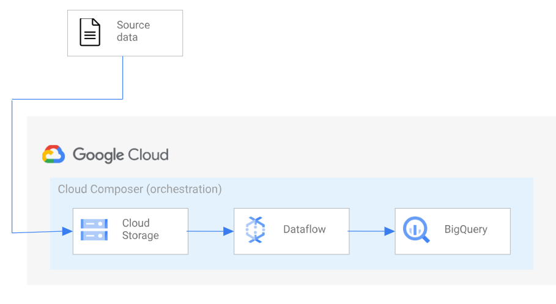

Related products and services
Google Cloud offers a portfolio of services for ETL including Cloud Data Fusion, Dataflow, and Dataproc. Key gcp services for ETL
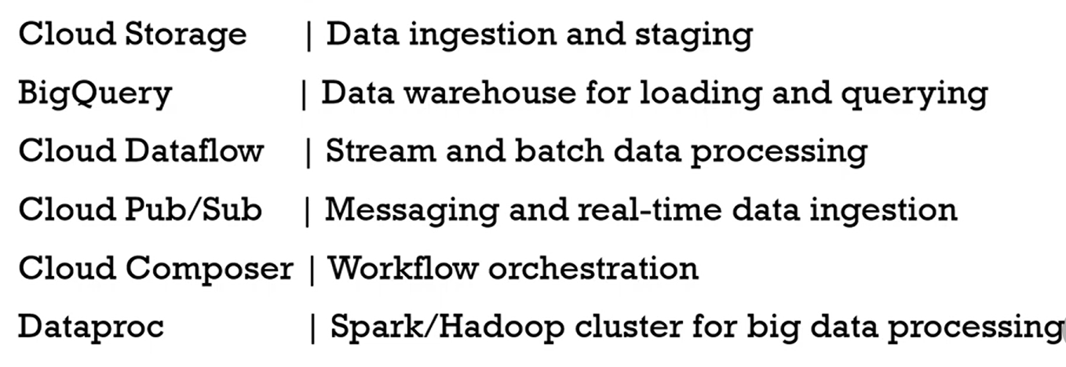

Key GCP Services for ETL/ELT Pipelines
GCP provides a range of tools, allowing you to choose the right service for your team's skills, data velocity, and required level of control.
Service Name | Function | Use Case
BigQuery | Serverless data warehouse | Target destination for analytics, increasingly used for ELT transformations via SQL.
Cloud Dataflow | Managed service for data processing | Unified batch and stream processing, based on Apache Beam. Ideal for complex, code-driven transformations.
Cloud Data Fusion | Fully managed, visual integration service | No-code/low-code ETL with a drag-and-drop interface and pre-built connectors. Good for teams wanting a managed, visual design layer.
Cloud Composer | Managed workflow orchestration | Built on Apache Airflow. Used for scheduling, monitoring, and managing complex multi-step pipelines across different services.
Cloud Dataproc | Managed Spark and Hadoop service | Running large-scale data transformations using open-source tools like Spark SQL or PySpark, without managing the underlying infrastructure.
Cloud Storage | Scalable object storage | Primary landing zone for raw source data and intermediate files in the pipeline.
Cloud Pub/Sub | Global messaging service | Ingesting real-time event streams; acts as the backbone for event-driven and streaming ETL architectures.

Common Pipeline Patterns
Different services can be combined into effective, serverless architectures to meet specific needs:
- Streaming Analytics: Pub/Sub → Dataflow → BigQuery (for near real-time insights).
- Batch Processing (Visual): Cloud Storage → Data Fusion → BigQuery (orchestrated by Cloud Composer).
- Big Data Transformations: Cloud Storage → Dataproc (Spark jobs) → BigQuery (for historical reprocessing or large joins).
ELT (Extract, Load, Transform) on GCP
Google Cloud often recommends an ELT approach, where raw data is loaded directly into BigQuery and transformed using its powerful, scalable SQL capabilities. Services like the BigQuery Data Transfer Service and Datastream facilitate the extraction and loading steps for this pattern.

Dataproc and Dataflow are data processing services on google cloud.

Dataflow ((Based on Apache Beam programming model)
Dataflow is a Google Cloud service that provides unified stream and batch data processing at scale. Use Dataflow to create jobs that read from one or more sources, transform the data, and write the data to a destination.
Dataflow is a fully managed platform for batch and streaming data processing service that can handle large amounts of data from continuous sources. It is serverless, so you do not need to provision infrastructure or create server cluster. It enables scalable ETL pipelines, real-time stream analytics, real-time ML, and complex data transformations using Apache Beam's unified model, all on serverless Google Cloud infrastructure.
Google Cloud's fully managed service that handles both real-time streaming data and massive batch loads making it perfect for ETL workloads. One of the coolest things about data flow is its unified approach to batch and streaming jobs. You write the same code for both, eliminating the need for separate systems and simplifying your ETL process and because data flow has horizontal and vertical autoscaling you can rest easy knowing your workloads will run even as your volume of data scales up and down. Plus, the unique vertical autoscaling feature dynamically adjusts memory allocation to workers protecting pipelines from crashing due to unexpected demand surges.
Built-in features like snapshots and Inplay streaming updates ensure data integrity and system uptime. Dataflow also provides real-time monitoring tools giving you full visibility into pipeline performance, you can think of it like a control center for your ETL pipelines. Dataflow's serverless nature means you only pay for what you use, not for idle resources. Plus, pre-built templates for common data movement tasks get you started quickly even without extensive coding knowledge.
The main goals of this architecture are to write data to warehouses like big query for analytics and business intelligence and to perform change data capture making transactional data available to Downstream applications

For Example:
I used to track my flying Bus, which shows schedules updated weekly so I never know whether my bus is running on time, early or late this unreliable data not only disrupts my day it also reflects a larger problem outdated information hinders businesses and frustrates customers.
Flying bus company process data from a variety of sources like GPS sensors, mobile apps and ticketing databases. In this architecture data is extracted from these sources and collected by pub sub or Kafka from there data flow takes over it transforms cleanses and analyzes the data in real time this processed data can be loaded into a data warehouse like big query and further analyzed with tools like looker allowing the bus company to monitor metrics like real-time ridership from their business business intelligence dashboards. Data flow can also write change data streams from Source databases into big query these changes can also be written to other transactional systems like alloy DB or Cloud SQL that power APIs This architecture allows for massive data processing with high scalability meaning I can get my bus schedule with a latency of less than 15 seconds and receive personalized notifications for my route, at the same time the bus company can respond to real-time surges in demand optimize routes and maximize customer satisfaction.
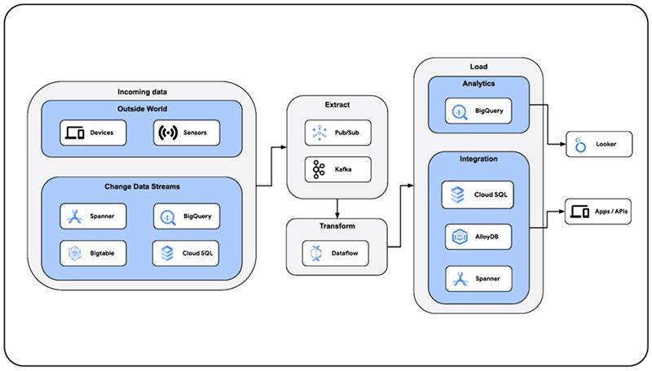

But the benefits extend beyond Transportation data flow can power real-time inventory updates to prevent stockouts in logistics it can enable predictive maintenance for shipping vehicles to reduce downtime and in financial services it can facilitate algorithmic trading based on the latest Market data.

Dataproc
Dataproc – (Apache Hadoop and spark cluster service) Dataproc is a managed Spark and Hadoop service that lets you take advantage of open source data tools for batch processing, querying, streaming, and machine learning.
Both Dataproc and Dataflow are data processing services on google cloud. What is common about both systems is they can both process batch or streaming data. Both also have workflow templates that are easier to use. But below are the distinguishing features about the two. Dataflow is designed for both batch and streaming pipelines with Apache Beam while Dataproc is mainly for batch processing Dataproc is mainly for batch processing. Dataflow is fully managed and auto-scales while Dataproc requires cluster management.
Dataproc is designed to run on clusters. Which makes it compatible with Apache Hadoop, hive and spark. It is significantly faster at creating clusters and can auto scale clusters without interruption of running job.

Dataflow is better if your data has no implementation with spark or Hadoop. It does not run on clusters, instead it is based on parallel data processing. As such data is split processed on multiple microprocessors to reduce processing time.
an Important note about Dataproc is, Dataprep provides data cleaning and automatically identifies anomalies in the data. It is integrated with Cloud Storage, BigTable and and BigQuery

Cloud Data Fusion (ETL Pipeline)
Data scientists and data engineers often need to build data pipeline to ingest, process and analyze usually involves multiple services that need to be coordinated and executed at the right time and under the write conditions.
These ETL and ELT type workflows ETL stands for Extract, Transform, Load. It's a process where data is gathered from multiple, diverse sources, then cleaned and converted into a usable format, and finally moved to a target system like a data warehouse for analysis, reporting, and decision-making.
ETL stands for extract, transform, and load and is a traditionally accepted way for organizations to combine data from multiple systems into a single database, data store, data warehouse, or data lake. ETL can be used to store legacy data, or—as is more typical today—aggregate data to analyze and drive business decisions. Google Cloud’s portfolio of services enabling ETL including BigQuery Data Transfer Service, Dataflow, and Dataform.

Looker is the full BI application/platform for enterprise data modeling and analytics.
Looker Studio is more of a data visualization and reporting tool within the BI ecosystem.
Looker
- Looker is a full-featured BI (Business Intelligence) platform owned by Google.
- It’s designed for advanced data modeling, exploration, and dashboarding.
- Uses LookML, a modeling language to define business logic and metrics.
- Typically used by enterprises for custom, governed analytics.
- Supports embedding analytics into apps, building data applications, and granular access control.
- Looker is a BI application focused on enterprise-grade analytics.

Looker Studio
- Formerly known as Google Data Studio.
- A free, easy-to-use data visualization and reporting tool.
- Connects to various data sources (including BigQuery, Google Sheets, Google Ads).
- Best for creating interactive dashboards and reports quickly.
- More suited for business users and marketers needing ad-hoc reporting.
- Looker Studio is primarily a data visualization/reporting tool, often considered part of BI but not a full BI platform like Looker.

BI Tools
Qlik Sense, looker, Tableau, PowerBI

Data Modeling
Data modeling is the process of creating a visual representation of either a whole information system or parts of it to communicate connections between data points and structures.
Data modeling is the process of creating a visual representation or a blueprint that defines the information collection and management systems of any organization. This blueprint or data model helps different stakeholders, like data analysts, scientists, and engineers, to create a unified view of the organization’s data. The model outlines what data the business collects, the relationship between different datasets, and the methods that will be used to store and analyze the data. It acts as a blueprint for databases, documenting how data is organized, stored, and accessed to ensure consistency, integrity, and efficient use for business intelligence and analysis. The process involves gathering requirements from stakeholders and progresses through conceptual, logical, and physical stages to build a robust and understandable data architecture.

Data model is a theoretical design of how structure will be structured, stored and used within a system. The goal of data modeling to illustrate the types of data used and stored within the system, the relationships among these data types, the ways the data can be grouped and organized and its formats and attributes.
Data models are built around business needs. Rules and requirements are defined upfront through feedback from business stakeholders so they can be incorporated into the design of a new system or adapted in the iteration of an existing one.
Data can be modeled at various levels of abstraction. The process begins by collecting information about business requirements from stakeholders and end users. These business rules are then translated into data structures to formulate a concrete database design. A data model can be compared to a roadmap, an architect’s blueprint or any formal diagram that facilitates a deeper understanding of what is being designed.
Data modeling employs standardized schemas and formal techniques. This provides a common, consistent, and predictable way of defining and managing data resources across an organization, or even beyond.
Ideally, data models are living documents that evolve along with changing business needs. They play an important role in supporting business processes and planning IT architecture and strategy. Data models can be shared with vendors, partners, and/or industry peers.

Why is data modeling important?
Organizations today collect a large amount of data from many different sources. However, raw data is not enough. You need to analyze data for actionable insights that can guide you to make profitable business decisions. Accurate data analysis needs efficient data collection, storage, and processing. There are several database technologies and data processing tools, and different datasets require different tools for efficient analysis.
Data modeling gives you a chance to understand your data and make the right technology choices to store and manage this data. In the same way an architect designs a blueprint before constructing a house, business stakeholders design a data model before they engineer database solutions for their organization.

Data modeling brings the following benefits:
- Reduces errors in database software development
- Facilitates speed and efficiency of database design and creation
- Creates consistency in data documentation and system design across the organization
- Facilitates communication between data engineers and business intelligence teams

What are the types of data models?
Data modeling typically begins by representing the data conceptually and then representing it again in the context of the chosen technologies. Analysts and stakeholders create several different types of data models during the data design stage. The following are three main types of data models:

1) Conceptual data model
Conceptual data models give a big picture view of data. They explain the following:

What data the system contains
Data attributes and conditions or constraints on the data
What business rules the data relates to
How the data is best organized
Security and data integrity requirements
The business stakeholders and analysts typically create the conceptual model. It is a simple diagrammatic representation that does not follow formal data modeling rules. What matters is that it helps both technical and nontechnical stakeholders to share a common vision and agree on the purpose, scope, and design of their data project.

Example of conceptual data models
For example, the conceptual data model for an auto dealership might show the data entities like this:

A Showrooms entity that represents information about the different outlets the dealership has
A Cars entity that represents the several cars the dealership currently stocks
A Customers entity that represents all the customers who have made a purchase in the dealership
A Sales entity that represents the information about the actual sale
A Salesperson entity that represents the information about all the salespeople who work for the dealership
This conceptual model would also include business requirements, such as the following:

Every car must belong to a specific showroom.
Every sale must have at least one salesperson and one customer associated with it.
Every car must have a brand name and product number.
Every customer must provide their phone number and email address.
Conceptual models thus act as a bridge between the business rules and the underlying physical database management system (DBMS). Conceptual data models are also called domain models.

2) Logical data model
Logical data models map the conceptual data classes to technical data structures. They give more details about the data concepts and complex data relationships that were identified in the conceptual data model, such as these:

Data types of the various attributes (for example, string or number)
Relationships between the data entities
Primary attributes or key fields in the data
Data architects and analysts work together to create the logical model. They follow one of several formal data modeling systems to create the representation. Sometimes agile teams might choose to skip this step and move from conceptual to physical models directly. However, these models are useful for designing large databases, called data warehouses, and for designing automatic reporting systems.

Example of logical data models
In our auto dealership example, the logical data model would expand the conceptual model and take a deeper look at the data classes as follows:

The Showrooms entity has fields such as name and location as text data and a phone number as numerical data.
The Customers entity has a field email address with the format xxx@example.com or xxx@example.com.yy. The field name can be no more than 100 characters long.
The Sales entity has a customer’s name and a salesperson’s name as fields, along with the date of sale as a date data type and the amount as a decimal data type.
Logical models thus act as a bridge between the conceptual data model and the underlying technology and database language that developers use to create the database. However, they are technology agnostic, and you can implement them in any database language. Data engineers and stakeholders typically make technology decisions after they have created a logical data model.

3) Physical data model
Physical data models map the logical data models to a specific DBMS technology and use the software’s terminology. For example, they give details about the following:

Data field types as represented in the DBMS
Data relationships as represented in the DBMS
Additional details, such as performance tuning
Data engineers create the physical model before final design implementation. They also follow formal data modeling techniques to make sure that they have covered all aspects of the design.

Example of physical data models
Suppose that the auto dealership decided to create a data archive in Amazon S3 Glacier Flexible Retrieval. Their physical data model describes the following specifications:

In Sales, the sale amount is a float data type, and the date of sale is a timestamp data type.
In Customers, the customer name is a string data type.
In S3 Glacier Flexible Retrieval terminology, a vault is the geographical location of your data.
Your physical data model also includes additional details such as which AWS Region you will create your vault in. The physical data model thus acts as a bridge between the logical data model and the final technology implementation.

Data modeling is the process of creating visual representations, or data models, that define an organization's data requirements, structures, and relationships. It acts as a blueprint for databases, documenting how data is organized, stored, and accessed to ensure consistency, integrity, and efficient use for business intelligence and analysis. The process involves gathering requirements from stakeholders and progresses through conceptual, logical, and physical stages to build a robust and understandable data architecture.
What Data Modeling Involves
Data modeling involves several key activities:
- Understanding Data Requirements: Working with business stakeholders to define what data is needed.
- Identifying Entities and Attributes: Defining the "things" or objects (entities) about which data is stored and the characteristics (attributes) of those entities.
- Establishing Relationships: Documenting how different data entities are connected to one another.
- Creating Visual Models: Using diagrams, text, and symbols to create a clear blueprint of the data structure.
Key Components of a Data Model
- Entities:
Independent objects or concepts that exist within the data system, such as a "Customer" or "Product".
- Attributes:
Characteristics that describe an entity, like a "Customer's" name or a "Product's" price.
- Relationships:
Connections between entities, such as a "Customer" placing many "Orders" (a one-to-many relationship).
You can watch this video to learn how to create a visual representation of data:

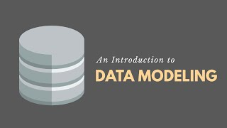
59s

Cody Baldwin
YouTube · 10 Dec 2023

Benefits of Data Modeling
- Improved Data Quality and Integrity:
Ensures data is accurate, consistent, and trustworthy by defining its structure and rules.
- Enhanced Collaboration:
Provides a common understanding for both IT and business teams, fostering better communication and alignment.
- Efficient Database Design:
Acts as a blueprint, guiding the development of databases and reducing errors during implementation.
- Better Decision-Making:
Organizes data in a clear, accessible way, making it easier to retrieve, analyze, and gain insights.
- Cost and Time Savings:
By planning data structures upfront, organizations can avoid redundant data, rework, and inefficient IT investments.
Levels of Data Modeling
The data modeling process typically moves through three main stages:
- 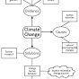
1. Conceptual Data Model:
Focuses on high-level business concepts and requirements, independent of technology.
- 
2. Logical Data Model:
Translates business concepts into more detailed data structures, defining entities, attributes, and relationships that can be implemented in a database.
- 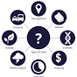
3. Physical Data Model:
The most detailed level, including technology-specific designs for a particular database system, specifying tables, data types, and other implementation details.

Cloudflare: Cloudflare provides performance and security to website owners via its intelligent global network. This is the system status for the Cloudflare service, both edge network and dashboard/APIs for management.

Cloudflare acts as a crucial intermediary between users and websites, sitting in front of servers to speed up content delivery and add layers of security by routing traffic through its massive global network. It uses a Content Delivery Network (CDN) to cache content closer to users for faster loading, protects against threats like DDoS attacks and bots with a Web Application Firewall (WAF), offers secure DNS (1.1.1.1), manages SSL, and provides tools for performance, reliability, and modern application development. Essentially, it makes websites faster, more secure, and more available for everyone.
コンテンツデリバリネットワーク
コンテンツデリバリネットワークとは、ウェブコンテンツをインターネット経由で配信するために最適化されたネットワークのことである。コンテンツ配信網とも呼ばれる。

Key Functions:
Content Delivery Network (CDN):
Stores copies (caches) of website files (images, CSS, etc.) on servers worldwide, delivering them from the nearest location to reduce latency and speed up load times.

DDoS Protection:
Absorbs and filters malicious traffic from Distributed Denial of Service attacks, preventing them from overwhelming the original server.

Web Application Firewall (WAF):
Blocks common web exploits, SQL injections, and other attacks before they reach your site.

Bot Management:
Identifies and mitigates unwanted automated traffic, like scrapers and credential stuffers, using machine learning.

DNS Management:
Provides fast and secure Domain Name System services, including its popular public DNS resolver 1.1.1.1 for privacy.

Security & Privacy:
Offers free SSL/TLS certificates, encrypts traffic, and protects user data through services like 1.1.1.1.

Load Balancing:
Distributes traffic across multiple servers to prevent any single server from getting overloaded, ensuring high availability.

How it Works:
Traffic Rerouting:
When you visit a Cloudflare-protected site, your request goes to Cloudflare's network first, not directly to the website's server.

Edge Processing:
Cloudflare's servers (edge nodes) analyze the request, apply security rules, and serve cached content if available.

Origin Connection:
If needed, the request is forwarded to the origin server, with the IP address hidden, making it harder for attackers to target.

In essence, Cloudflare acts as a smart, protective layer that optimizes every internet connection for performance and security, making the web work better for both users and website owners.

Top Cloudflare CDN Alternatives
- Fastly Deliver.
- CloudFront CDN.
- Akamai CDN.
- Google Cloud CDN.
- Microsoft Azure CDN.
- Tata Communications CDN.
- StackPath CDN (Legacy)
- Medianova CDN.

AWS Lambda is a serverless compute service provided by Amazon Web Services (AWS) that allows you to run code without provisioning or managing servers. This means you can focus on writing your application code, and AWS handles all the underlying infrastructure, including server provisioning, scaling, maintenance, and patching.
Amazon SageMaker is a fully managed machine learning service from Amazon Web Services (AWS) that provides a comprehensive platform for data scientists and developers to build, train, and deploy models in the cloud. It includes tools for every step of the machine learning workflow, such as a unified integrated development environment (IDE) called SageMaker Studio for data preparation, model development, and deployment. This allows users to focus on building models instead of managing infrastructure.
Machine Learning Service - Free Amazon SageMaker AI - AWS
Build, train, and deploy machine learning models easily with Amazon SageMaker AI on the AWS Free Tier.
AWS Bedrock is a fully managed service that provides a serverless platform for building and scaling generative AI applications. It gives developers access to leading foundation models from companies like Amazon and others, along with tools for fine-tuning, security, and deployment. This allows organizations to create applications, such as chatbots, content moderation tools, and agents that connect to proprietary data, without needing to develop and manage custom models themselves.

Cloud Trace, a distributed tracing system for Google Cloud, helps you understand how long it takes your application to handle incoming requests from users or other applications, and how long it takes to complete operations like RPC calls performed when handling the requests. Trace can also help you when you are developing a service, developing an agentic application, or troubleshooting a failure. For example, it can help you understand how requests are processed in a complicated microservices architecture, and it might help you identify which logs to examine.

Filestore:
Filestore is a fully managed network-attached storage (NAS) service from Google Cloud, designed for applications that require a file system interface and shared access. It offers high-performance, low-latency storage for workloads like media rendering, data analytics, and content management, supporting up to 100 TiB capacity and 26 GiB/s throughput.
GCP's Filestore is a managed file storage service for applications that require a file system interface and a shared file system for data. It gives the user a native experience for standing up managed network detached storage with their VM in the compute engine and Google Kubernetes Engine. It offers low latency for file operations, therefore making it perfect for workloads like data analytics, media rendering, genomic processing, or other media-intensive applications. It provides performance tier and storage capacity which enables users to tune the file system for a particular workload.
Key Features
- Fully Managed NFS: Filestore provides Network File System (NFSv3) file servers, making it easy to mount storage on Compute Engine VMs, Google Kubernetes Engine (GKE) clusters, or on-premises servers.
- Performance Tiers: Offers Basic (SSD/HDD), Enterprise, and High Scale tiers, allowing users to optimize for cost or performance-critical workloads.
- Shared Storage: Enables multiple clients (VMs or containers) to read and write to the same file system simultaneously.
- Typical Applications: Ideal for web hosting, software development, AI training, and high-performance computing (HPC).
Use Cases
Filestore has the following principal use cases:
- Application Migration: It can be used to provide a file storage interface to applications.
- Media rendering: It is also used to reduce latency while media rendering.
- Electronic Design Automation: Data management is one of its premium features.
- Data analytics: Analysis of Data can also be done to get bossiness insights.
- Genomics processing: The speed, scalability, and security provided by Filestore are highly effective for Genome sequencing as it needs an incredible amount of raw data, on the order of billions of data points per person.
- Web content management: Managing and serving web content is made simple by the use of Filestore.
Benefits:
- High Speed: Low latency, high IOPS for metadata-intensive tasks.
- Ease of Use: Fully managed, reducing the operational burden of managing file servers.
- Simplified Migration: Facilitates moving legacy applications to the cloud without major re-architecting.
Filestore instances can be managed via the Cloud Console, API, or gcloud commands.

Firestore:
Cloud Firestore is a NoSQL document database that lets you easily store, sync, and query data for your mobile and web apps - at global scale.
Firestore is a flexible, scalable database for mobile device, web, and server development from Firebase and Google Cloud. It's very easy to get started with Firestore and write rich and powerful applications. Like Firebase Realtime Database, it keeps your data in sync across client apps through realtime listeners and offers offline support for mobile and web so you can build responsive apps that work regardless of network latency or Internet connectivity. Cloud Firestore also offers seamless integration with other Firebase and Google Cloud products, including Cloud Run functions.
Cloud Firestore has two editions - Firestore Standard edition and Firestore Enterprise edition to meet different needs.
Enterprise-grade document database with MongoDB compatibility
Build AI, web, and mobile applications with a fully managed, serverless document database that provides virtually unlimited scalability and industry-leading availability.
Firestore is a flexible, scalable JSON database for mobile device, web, and server development from Google Cloud. It's very easy to get started with Firestore and write rich and powerful applications. Learn best practices for building apps that use Firestore, including data location, document IDs, field names, indexes, read and write operations, and designing for scale.
Features
MongoDB compatibility
Use a familiar MongoDB wire-compatible API on Firestore's serverless database service. You can now use your existing MongoDB application code, drivers, and integrations, in addition to the open-source ecosystem of MongoDB integrations, to quickly build applications for common use cases. Learn more.
Real-time synchronization
Develop rich applications utilizing advanced pipeline query capabilities, including full-text search, geospatial, and robust offline data handling. Built-in real-time sync facilitates offline-first or collaborative app development for mobile, web, and wearables. Power workloads in media, gaming, content management, messaging, location-based services, retail, hospitality, and business apps. Learn more.
Serverless
Focus on your application development using a fully managed, serverless document database that effortlessly scales up or down to meet any demand, with no manual sharding, maintenance windows, or administrative downtime. Enjoy multi-region replication with strong consistency, ACID-compliant multi-document transactions and virtually unlimited scalability without worrying about managing the underlying database infrastructure.
Gen AI ready
Turn simple text prompts into live, Firestore-backed applications in seconds with our Google AI Studio integration. Use remote MCP support to securely connect your favorite AI agents and developer tools directly to Firestore. Easily build generative AI applications with Firestore vector search, LangChain, and LlamaIndex integrations. Use turnkey extensions to integrate Firestore with popular AI services with a few clicks, enabling use cases such as automated embedding generation, language translations, image classification, and more.
Datastore compatibility
Use the familiar Datastore SDKs and wire compatibility on Firestore's serverless database service for seamless transition for existing Datastore applications. Bring Datastore’s hierarchical data structures with Entities and Kinds into Firestore’s collection-based model with richer query capabilities without breaking changes. Learn more.
Powerful query engine
Firestore allows you to run sophisticated queries including vector search, full-text search, geospatial queries, and ACID transactions against your JSON or BSON-compatible document data. This gives you more flexibility in the way you structure your data and allows you to unify your database and search operations.
Security
Firestore seamlessly integrates with Cloud Identity and Access Management, Cloud Identity Platform, and Firebase Authentication, to enable customizable identity-based security access controls and enables data validation using a configuration language.
Multi-region replication
Firestore offers automatic multi-region replication with strong consistency and industry-leading high availability of up to 99.999% SLA. This ensures that your data is safe and available, even when disasters strike.

Develop responsive mobile and web apps
For mobile and web app backends, Firestore acts as a powerful, managed database solution that directly addresses key modern mobile and web app requirements. Client-side SDKs (iOS, Android, Web) feature real-time updates and provide robust support with automatic data syncing, ensuring accessibility anytime, anywhere.
You can now significantly accelerate your build process and focus on delivering core application value to your users, rather than getting bogged down in complex backend infrastructure development and maintenance.
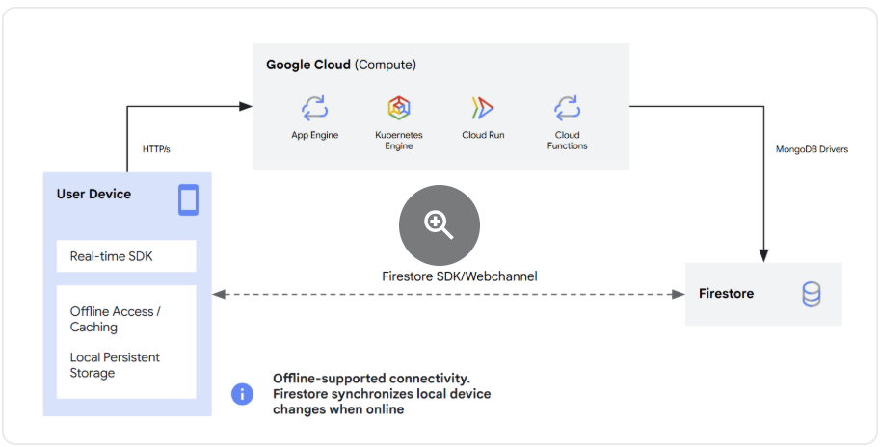

Google Cloud Datastore vs Firestore: Comparison
Datastore and Firestore are both NoSQL document databases offered by Google Cloud, but they have key differences:
- Firestore: The newer, more feature-rich database. It offers stronger consistency guarantees, mobile and web client libraries for direct client access, and more advanced querying capabilities. It's generally the recommended option for new projects.
- Datastore: An older, simpler database. It offers eventual consistency, which can be sufficient for many use cases, and is often cheaper than Firestore. It's a good choice for simpler applications where strong consistency isn't critical and cost is a primary concern. Datastore is now available in Datastore mode, which is essentially Firestore in Datastore mode, offering some of the benefits of Firestore while maintaining Datastore's pricing and simplicity.
Firestore and Datastore share the same underlying storage technology and infrastructure, but they function as different modes of the same product. Firestore is the modern successor to Datastore, which now operates in two modes: Native mode (for mobile/web, real-time) and Datastore mode (for backend services, API compatibility). Google eventually merged them under: Firestore in Datastore mode
When you create a Firestore database, you must choose between two modes: Native mode or Datastore mode. You can have both Native mode and Datastore mode databases in the same project, but each database will be of a single type.
We recommend the following when choosing a database mode:
Use Firestore in Native mode for all new applications (server, mobile, and web).
Firestore in Native mode uses a document-based data model that aligns with industry standards. In addition to a strongly consistent and scalable database, Firestore in Native mode provides real-time data syncing and backend-as-a-service features.
Use Firestore in Datastore mode if your app depends on the Datastore API.
Datastore Mode is fully supported and is recommended for applications with a dependency on the Datastore API. Native mode and Datastore mode share an underlying storage layer with the same availability, consistency, and scaling capabilities.

Google Front End (GFE)
This is an infrastructure service common to all Google cloud services. The GFE accepts incoming requests and forwards them to the relevant Google service (Firestore service in this context). It also provides other important functionalities, including protection against Denial of Service attacks.

Private Service Connect (PSC) (connecting different networks in the cloud)
Private Service Connect is a capability of Google Cloud networking that allows consumers to access managed services privately from inside their VPC network. Similarly, it allows managed service producers to host these services in their own separate VPC networks and offer a private connection to their consumers. For example, when you use Private Service Connect to access Cloud SQL, you are the service consumer, and Google is the service producer.
With Private Service Connect, consumers can use their own internal IP addresses to access services without leaving their VPC networks. Traffic remains entirely within Google Cloud. Private Service Connect provides service-oriented access between consumers and producers with granular control over how services are accessed.
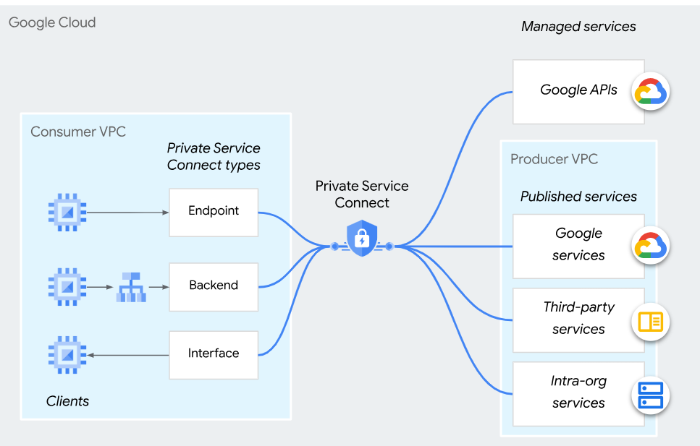
Private Service Connect lets you send traffic to endpoints and backends that forward the traffic to managed services, including Google APIs and published services. Private Service Connect interfaces let managed services initiate connections to consumer VPC networks.

Choosing a Private Service Connect feature
The following table summarizes which Private Service Connect features to use for different use cases.
Use case | Private Service Connect feature
Consume services | - Endpoints provide layer 4 connectivity to services.  - If you need load balancer features, such as custom URLs or advanced traffic management, use backends.
Produce services | - Published services let consumers send requests to your service.  - If you need to initiate connections to consumers, use interfaces.

Creates a private and secure connection from your VPCs to Google, third parties, or your own services.
Producer and Consumer VPC
In the context of Google Cloud Platform (GCP), a producer VPC is a Virtual Private Cloud network that hosts managed services and is owned and managed by Google. The consumer VPC is a network that uses these services and is owned by the end-user or application developer. The producer VPC network is isolated from the consumer VPC network, ensuring that the services are secure and private. The consumer VPC network can access the services in the producer VPC network through a private connection, such as Private Service Connect (PSC) or VPC Peering. This setup allows for secure and private access to managed services while maintaining the separation of the producer and consumer roles.
Consumer: Private VPC created application project for creating endpoints to consume the published services by google or third party. Client machine at the consumer side can connect to the endpoint using secondary NIC.
Producer: Two VPCs needed in application project publish service, Private VPC created application and NAT VPC create service attachment
Google managed service? producer and consumer service? Google cloud Endpoint
Google Cloud Endpoints is an API management and API gateway solution that helps you secure, monitor, and manage APIs running on Google Cloud or elsewhere.

How PSC Works in GCP (The Simplified Tech Version)
In GCP, you have your own private network called a VPC (Virtual Private Cloud). You want to connect to a service (like a database, an AI tool, or Google APIs) that lives in another network.
With PSC, the service provider creates a Service Attachment (the plug), and you create an Endpoint (the socket) inside your network.
- It uses an Internal IP Address: The service gets a local IP address inside your network (e.g., 10.0.0.5).
- No Public Internet: Your data travels across Google’s private, lightning-fast fiber-optic cables, completely bypassing the public internet.
- Total Isolation: The two networks don't actually merge. You can't see their internal files, and they can't see yours. You can only talk to that one specific service.
Before PSC, connecting different networks in the cloud was a headache. PSC solved the three biggest problems:
- Security: Your data never touches the scary public internet.
- No IP Conflicts: In the past, if your network used the same IP numbers as the vendor's network (e.g., you both used 192.168.1.X), you couldn't connect them easily. PSC doesn't care; it acts like a translator, so IP addresses never clash.
- Simplicity: It turns complex cloud networking into a simple "point and click" connection.
Summary: PSC is a secure, private bridge in Google Cloud that lets you consume or provide services privately, safely, and easily, without exposing anything to the public internet.

Private Service Access (PSA) vs Private Service Connect (PSC) vs Private Google Access (PGA)
In Google Cloud, PSC (Private Service Connect) and PSA (Private Services Access) are both ways to connect to services privately, but they solve different problems.
Here's a simple explanation.
Feature | PSC (Private Service Connect) | PSA (Private Services Access)
Purpose | Connect privately to a service | Allow Google-managed services to use your VPC
Uses private IP? | ✅ Yes | ✅ Yes
Common use | Access APIs or services privately | Create databases like Cloud SQL with private IP
Communication | Consumer ↔ Service | Your VPC ↔ Google-managed network

1. Private Services Access (PSA)
What is it?
PSA allows Google-managed services (like Cloud SQL or Memorystore) to get an IP address from your VPC so you can access them privately.
Normally:
VM
|
Internet
|
Cloud SQL
With PSA:
Your VPC
|
Private Connection
|
Cloud SQL (Private IP)
No internet is involved.
Example
Suppose you create:
- VPC: production-vpc
- Cloud SQL PostgreSQL
If you enable Private IP, Google asks you to configure Private Services Access.
Terraform creates:
- Reserved IP range
- VPC Peering with Google's service network
Then your VM can connect like:
10.1.0.10 ---> 10.50.0.5 (Cloud SQL)
instead of using a public IP.
Services that commonly use PSA
- Cloud SQL
- Memorystore
- AlloyDB
- Filestore
- Other Google-managed services with private IPs

2. Private Service Connect (PSC)
What is it?
PSC lets you privately connect to a service through an endpoint.
That service could be:
- A Google API
- Another company's service
- A service published by another VPC
- Your own service
Instead of going over the internet, traffic stays on Google's network.
Example 1: Access Google APIs privately
Normally:
VM
|
Internet
|
storage.googleapis.com
Using PSC:
VM
|
PSC Endpoint (Private IP)
|
Google Storage API
Your VM calls a private IP instead of the public endpoint.

Example 2: Connect to another team's service
Suppose Team A has an application.
Service Producer
----------------
Load Balancer
|
Application
Team B wants to use it.
Instead of exposing it publicly:
Team B VPC
|
PSC Endpoint
|
Google Network
|
Team A Service
Everything stays private.

Simple analogy
Imagine Google Cloud is a large office building.
PSA
You rent an office (your VPC).
You ask the building manager:
"Please build my database room inside the building so I don't have to walk outside."
The manager creates the room in a Google-managed area but connects it directly to your office.
That's Private Services Access.

PSC
Now another company in the building offers a service.
Instead of leaving the building and coming back through the main entrance, they install a private door directly between your offices.
That's Private Service Connect.

Key difference
PSA
Used when Google creates a managed resource with a private IP in your VPC context.
Your VPC
|
VPC Peering
|
Google Managed Service
(Cloud SQL, Memorystore)

PSC
Used when you privately consume or publish a service.
Consumer VPC
|
PSC Endpoint
|
Producer Service

When would you use each?
Use PSA when you need:
- Cloud SQL with a private IP
- Memorystore with a private IP
- AlloyDB with a private IP
- Other Google-managed services that require VPC peering
Use PSC when you need:
- Private access to Google APIs
- Private access to a service hosted in another VPC
- To publish your own service privately to other projects or organizations
- Private connectivity without traditional VPC peering
Quick way to remember
- PSA = Private access to Google-managed resources (such as Cloud SQL) by extending your VPC to Google's managed network.
- PSC = Private connection to a service (Google APIs or producer services) through a private endpoint, without exposing traffic to the public internet.

Cloud KMS (customer-managed encryption keys in other Google Cloud services to secure your resources.)
Secret Manager
Connecting to GitHub with SSH (https://docs.github.com/en/authentication/connecting-to-github-with-ssh)
You can connect to GitHub using the Secure Shell Protocol (SSH), which provides a secure channel over an unsecured network.
Error:
sg0701577@devenv-shell-env:/mnt/c/Users/SG0701577/KBArticle/ecs.hd-chatbot-platform-terraform$ git pull
git@github.com: Permission denied (publickey).
fatal: Could not read from remote repository.
Please make sure you have the correct access rights
and the repository exists.

GitHub SSH Key Configuration
1. Generate SSH keys
Run: ssh-keygen -t ed25519 -C "<your-email>" and press Enter to accept the default file location.
2. Verify the SSH keys
Run cd ~/.ssh && ls. You should see id_ed25519 (private key) and id_ed25519.pub (public key).
3. Copy the public key
Run cat ~/.ssh/id_ed25519.pub, copy the complete output, and add it under GitHub → Settings → SSH and GPG keys → New SSH key.
4. Configure SSO
In GitHub SSH and GPG keys, click Configure SSO next to the newly created SSH key and authorize it for the required organization.
5. Test the connection
Run ssh -T git@github.com to verify that SSH authentication is configured successfully.

Q) How to explain 3 tier application architecture in gcp devops interview
For a GCP DevOps interview, explain a 3-tier architecture in terms of traffic flow + GCP services + DevOps responsibilities. A good answer should sound practical rather than just defining the three tiers.
Interview-ready answer
“A 3-tier application architecture separates the application into three layers: the presentation tier, application tier, and database tier.
In GCP, for example, users can access the application through Cloud DNS, with traffic going through Cloud Load Balancing. The presentation tier can be hosted on services such as Cloud Run, GKE, or a frontend hosting platform.
The application or business-logic tier runs separately, for example on Cloud Run or GKE. This tier handles APIs, authentication, business logic, and communication with backend services.
The database tier contains persistent data, typically using Cloud SQL, Spanner, Firestore, or another appropriate datastore.
A typical request would flow as:
User → Cloud DNS → Load Balancer → Frontend/Application → Backend API → Database
From a DevOps perspective, I would implement CI/CD using Cloud Build or GitHub Actions, store container images in Artifact Registry, deploy to Cloud Run or GKE, and use Terraform for infrastructure as code.
For security, I would use IAM, service accounts, Secret Manager, VPC controls, and least-privilege access. For monitoring, I would use Cloud Monitoring, Cloud Logging, and Cloud Trace.
The main advantage of the 3-tier architecture is separation of concerns. Each tier can be scaled, deployed, secured, and maintained independently.”
Draw it on the interview whiteboard
Plain Text
USERS
|
v
+--------------+
| Cloud DNS |
+--------------+
|
v
+--------------------+
| Load Balancer / CDN|
+--------------------+
|
v
+--------------------------+
| PRESENTATION TIER |
| Cloud Run / GKE / Web |
+--------------------------+
|
HTTPS / API
|
v
+--------------------------+
| APPLICATION TIER |
| Cloud Run / GKE |
| Business Logic / APIs |
+--------------------------+
|
v
+--------------------------+
| DATABASE TIER |
| Cloud SQL / Spanner etc. |
+--------------------------+

Then explain the DevOps side
A strong interview answer goes one step further:
1. Source code
Plain Text
Developer
|
v
GitHub / GitLab
2. CI pipeline
Plain Text
Git Push
|
v
Cloud Build / GitHub Actions
|
+--> Unit Tests
+--> Security Scan
+--> Docker Build
|
v
Artifact Registry
3. CD pipeline
Plain Text
Artifact Registry
|
v
Cloud Run / GKE
|
+--> Dev
+--> QA
+--> Production
4. Infrastructure
“I would provision the GCP infrastructure using Terraform rather than manually creating resources. Terraform would manage the VPC, load balancer, Cloud Run/GKE, Cloud SQL, IAM, service accounts, and other infrastructure.”
A practical example
Suppose you're deploying an e-commerce application.
Plain Text
Customer
|
v
Load Balancer
|
v
Frontend
|
v
Product / Order API
|
+-----------> Cloud SQL
|
+-----------> Memorystore
|
+-----------> Pub/Sub
You could explain:
- Presentation: product pages and frontend.
- Application: product, order, payment and authentication APIs.
- Database: customer, product and order data.
- Pub/Sub: asynchronous operations such as order processing or notifications.
- Memorystore: caching frequently accessed data.
- Cloud Monitoring/Logging: application and infrastructure observability.
- Secret Manager: database credentials/API secrets.
- IAM: controls which service can access which resource.
A good DevOps-level closing statement
“I wouldn't treat the three tiers as just three servers. In GCP, I would design them as independently deployable and scalable components. For example, Cloud Run can provide the application tier, Cloud SQL can provide the relational database tier, and a frontend can be deployed separately. CI/CD automates the promotion between environments, Terraform manages infrastructure, IAM handles access control, and Cloud Monitoring and Logging provide observability.”
That last part is particularly useful in a DevOps interview, because it demonstrates that you understand both application architecture and the operational lifecycle.

Q) How gcp handles encryption
In a GCP DevOps interview, explain encryption as “encryption at rest + encryption in transit + key management.”
Interview-ready answer
“GCP provides encryption by default for data at rest and encryption for data in transit. For most Google Cloud services, I don't have to manually configure encryption for basic protection.
For data at rest, Google uses Google-managed encryption keys by default. If the organization needs more control over the keys, we can use Cloud KMS with customer-managed encryption keys, or CMEK, and in some scenarios customer-supplied or externally managed keys.
For data in transit, GCP uses TLS to protect communication between users, applications, and Google Cloud services.
From a DevOps perspective, I would use Cloud KMS for key management, IAM to control who can use the keys, Secret Manager for application secrets, and audit logging to track key and resource access.”
1. Encryption at rest
Think:
Application
|
v
GCP Service
|
v
Encrypted Data
|
+---- Google-managed keys
|
+---- CMEK --> Cloud KMS
For example, data stored in services such as Cloud Storage, Cloud SQL, and Compute Engine persistent disks is encrypted at rest by default.
There are different levels of key control:
Option | Who manages the key? | Typical use
Google-managed | Google | Default / most workloads
CMEK | Customer via Cloud KMS | Compliance and greater key control
CSEK | Customer supplies key | Special use cases
EKM | External key manager | Highly controlled environments
2. Encryption in transit
When a user accesses your application:
User
|
HTTPS / TLS
|
v
Load Balancer
|
HTTPS / TLS
|
v
Cloud Run / GKE
|
TLS
|
v
Database / Other Services
TLS protects data while it is moving between endpoints.
For example, you might configure HTTPS on a Google Cloud Load Balancer and use certificates managed through Certificate Manager.
3. Cloud KMS
If the interviewer asks “What is Cloud KMS?”, say:
“Cloud KMS is a managed service for creating, storing, controlling, and using cryptographic keys. I can use it with CMEK to give my organization more control over encryption keys and their lifecycle.”
For example:
Cloud Storage / Cloud SQL / Compute
|
| CMEK
v
Cloud KMS
|
v
Encryption Key
You can control:
- Who can use the key
- Who can administer the key
- Key rotation
- Key versions
- Key disabling/destroying
- Audit logging
4. Don't confuse Secret Manager and KMS
This is a common interview question.
Secret Manager → stores secrets.
DB password
API key
OAuth secret
Certificate/private secret
|
v
Secret Manager
Cloud KMS → manages cryptographic keys.
Encryption key
|
v
Cloud KMS
You can use them together, but they solve different problems.
5. A strong DevOps example
Suppose you have:
Internet
|
v
Load Balancer
|
v
Cloud Run
|
+------> Cloud SQL
|
+------> Cloud Storage
|
+------> Secret Manager
|
+------> Cloud KMS
I'd explain:
“I would enforce HTTPS/TLS for traffic in transit. GCP services provide encryption at rest by default. If the application has compliance requirements, I'd use CMEK with Cloud KMS for services that support it. Application credentials would go into Secret Manager rather than source code or environment files. IAM would restrict access to both secrets and encryption keys, and Cloud Audit Logs would provide an audit trail.”
One sentence to remember
“GCP encrypts data at rest by default and protects data in transit with TLS; when I need additional control, I use Cloud KMS and CMEK, while Secret Manager handles application secrets and IAM controls access.”

